**normal-fungal-serious-1280-every-5-test-and-validation-80-epochs-and-originals-batch-256**

true positives = 100  
true negatives = 526  
false positives = 42  
false negatives = 35  
not confident of any answer = 69  
total = 772  
  
sensitivity = 0.7407  
specificity = 0.9261  
precision = 0.7042  
recall = 0.7407

check with a GP#200  
**Analysis by this app:**normal = 0%; non-serious = 0%; check with a GP = 100%;   
It is most likely that the nail indicates something that warrants a second opinion and you should seek medical advice. (Confidence score is 100%)×

 check with a GP#390  
**Analysis by this app:**normal = 0%; non-serious = 0%; check with a GP = 100%;   
It is most likely that the nail indicates something that warrants a second opinion and you should seek medical advice. (Confidence score is 100%)×

 check with a GP#400  
**Analysis by this app:**normal = 0%; non-serious = 0%; check with a GP = 100%;   
It is most likely that the nail indicates something that warrants a second opinion and you should seek medical advice. (Confidence score is 100%)×

 check with a GP#275  
**Analysis by this app:**normal = 0%; non-serious = 0%; check with a GP = 100%;   
It is most likely that the nail indicates something that warrants a second opinion and you should seek medical advice. (Confidence score is 100%)×

 check with a GP#10  
**Analysis by this app:**normal = 0%; non-serious = 0%; check with a GP = 100%;   
It is most likely that the nail indicates something that warrants a second opinion and you should seek medical advice. (Confidence score is 100%)×

 check with a GP#425  
**Analysis by this app:**normal = 0%; non-serious = 0%; check with a GP = 100%;   
It is most likely that the nail indicates something that warrants a second opinion and you should seek medical advice. (Confidence score is 100%)×

 check with a GP#270  
**Analysis by this app:**normal = 0%; non-serious = 0%; check with a GP = 99%;   
It is most likely that the nail indicates something that warrants a second opinion and you should seek medical advice. (Confidence score is 99%)×

 check with a GP#395  
**Analysis by this app:**normal = 0%; non-serious = 1%; check with a GP = 99%;   
It is most likely that the nail indicates something that warrants a second opinion and you should seek medical advice. (Confidence score is 99%)×

 check with a GP#350  
**Analysis by this app:**normal = 0%; non-serious = 1%; check with a GP = 99%;   
It is most likely that the nail indicates something that warrants a second opinion and you should seek medical advice. (Confidence score is 99%)×

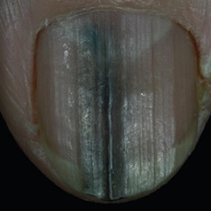  
 check with a GP#600  
**Analysis by this app:**normal = 1%; non-serious = 0%; check with a GP = 99%;   
It is most likely that the nail indicates something that warrants a second opinion and you should seek medical advice. (Confidence score is 99%)×

 check with a GP#465  
**Analysis by this app:**normal = 1%; non-serious = 0%; check with a GP = 99%;   
It is most likely that the nail indicates something that warrants a second opinion and you should seek medical advice. (Confidence score is 99%)×

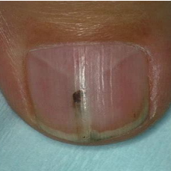  
 check with a GP#690  
**Analysis by this app:**normal = 1%; non-serious = 1%; check with a GP = 99%;   
It is most likely that the nail indicates something that warrants a second opinion and you should seek medical advice. (Confidence score is 99%)×

 check with a GP#475  
**Analysis by this app:**normal = 1%; non-serious = 0%; check with a GP = 99%;   
It is most likely that the nail indicates something that warrants a second opinion and you should seek medical advice. (Confidence score is 99%)×

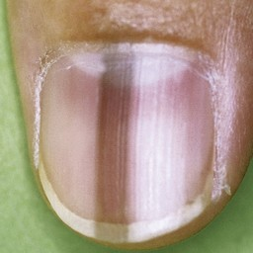  
 check with a GP#580  
**Analysis by this app:**normal = 1%; non-serious = 1%; check with a GP = 98%;   
It is most likely that the nail indicates something that warrants a second opinion and you should seek medical advice. (Confidence score is 98%)×

 check with a GP#365  
**Analysis by this app:**normal = 1%; non-serious = 1%; check with a GP = 98%;   
It is most likely that the nail indicates something that warrants a second opinion and you should seek medical advice. (Confidence score is 98%)×

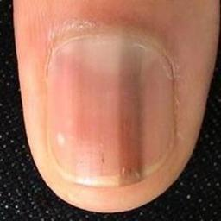  
 check with a GP#560  
**Analysis by this app:**normal = 1%; non-serious = 1%; check with a GP = 98%;   
It is most likely that the nail indicates something that warrants a second opinion and you should seek medical advice. (Confidence score is 98%)×

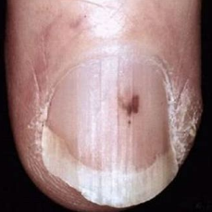  
 check with a GP#730  
**Analysis by this app:**normal = 0%; non-serious = 2%; check with a GP = 98%;   
It is most likely that the nail indicates something that warrants a second opinion and you should seek medical advice. (Confidence score is 98%)×

 check with a GP#145  
**Analysis by this app:**normal = 2%; non-serious = 0%; check with a GP = 98%;   
It is most likely that the nail indicates something that warrants a second opinion and you should seek medical advice. (Confidence score is 98%)×

 check with a GP#135  
**Analysis by this app:**normal = 1%; non-serious = 2%; check with a GP = 98%;   
It is most likely that the nail indicates something that warrants a second opinion and you should seek medical advice. (Confidence score is 98%)×

 check with a GP#360  
**Analysis by this app:**normal = 2%; non-serious = 1%; check with a GP = 97%;   
It is most likely that the nail indicates something that warrants a second opinion and you should seek medical advice. (Confidence score is 97%)×

 check with a GP#220  
**Analysis by this app:**normal = 3%; non-serious = 0%; check with a GP = 97%;   
It is most likely that the nail indicates something that warrants a second opinion and you should seek medical advice. (Confidence score is 97%)×

 check with a GP#230  
**Analysis by this app:**normal = 1%; non-serious = 2%; check with a GP = 97%;   
It is most likely that the nail indicates something that warrants a second opinion and you should seek medical advice. (Confidence score is 97%)×

 check with a GP#65  
**Analysis by this app:**normal = 1%; non-serious = 2%; check with a GP = 96%;   
It is most likely that the nail indicates something that warrants a second opinion and you should seek medical advice. (Confidence score is 96%)×

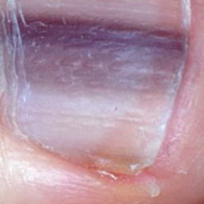  
 check with a GP#525  
**Analysis by this app:**normal = 0%; non-serious = 4%; check with a GP = 96%;   
It is most likely that the nail indicates something that warrants a second opinion and you should seek medical advice. (Confidence score is 96%)×

 check with a GP#240  
**Analysis by this app:**normal = 3%; non-serious = 1%; check with a GP = 96%;   
It is most likely that the nail indicates something that warrants a second opinion and you should seek medical advice. (Confidence score is 96%)×

 check with a GP#515  
**Analysis by this app:**normal = 1%; non-serious = 3%; check with a GP = 96%;   
It is most likely that the nail indicates something that warrants a second opinion and you should seek medical advice. (Confidence score is 96%)×

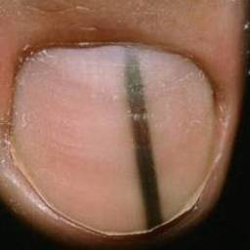  
 check with a GP#545  
**Analysis by this app:**normal = 3%; non-serious = 2%; check with a GP = 95%;   
It is most likely that the nail indicates something that warrants a second opinion and you should seek medical advice. (Confidence score is 95%)×

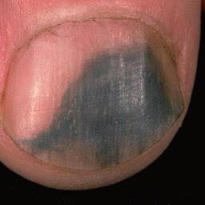  
 check with a GP#645  
**Analysis by this app:**normal = 4%; non-serious = 1%; check with a GP = 95%;   
It is most likely that the nail indicates something that warrants a second opinion and you should seek medical advice. (Confidence score is 95%)×

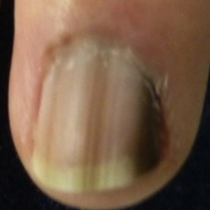  
 check with a GP#590  
**Analysis by this app:**normal = 5%; non-serious = 0%; check with a GP = 95%;   
It is most likely that the nail indicates something that warrants a second opinion and you should seek medical advice. (Confidence score is 95%)×

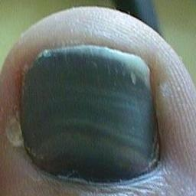  
 check with a GP#615  
**Analysis by this app:**normal = 1%; non-serious = 4%; check with a GP = 95%;   
It is most likely that the nail indicates something that warrants a second opinion and you should seek medical advice. (Confidence score is 95%)×

 check with a GP#260  
**Analysis by this app:**normal = 1%; non-serious = 4%; check with a GP = 95%;   
It is most likely that the nail indicates something that warrants a second opinion and you should seek medical advice. (Confidence score is 95%)×

  
 check with a GP#745  
**Analysis by this app:**normal = 2%; non-serious = 3%; check with a GP = 95%;   
It is most likely that the nail indicates something that warrants a second opinion and you should seek medical advice. (Confidence score is 95%)×

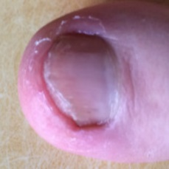  
 check with a GP#685  
**Analysis by this app:**normal = 4%; non-serious = 1%; check with a GP = 95%;   
It is most likely that the nail indicates something that warrants a second opinion and you should seek medical advice. (Confidence score is 95%)×

  
 check with a GP#675  
**Analysis by this app:**normal = 4%; non-serious = 1%; check with a GP = 95%;   
It is most likely that the nail indicates something that warrants a second opinion and you should seek medical advice. (Confidence score is 95%)×

 check with a GP#310  
**Analysis by this app:**normal = 4%; non-serious = 2%; check with a GP = 94%;   
It is most likely that the nail indicates something that warrants a second opinion and you should seek medical advice. (Confidence score is 94%)×

 check with a GP#215  
**Analysis by this app:**normal = 5%; non-serious = 1%; check with a GP = 94%;   
It is most likely that the nail indicates something that warrants a second opinion and you should seek medical advice. (Confidence score is 94%)×

 check with a GP#330  
**Analysis by this app:**normal = 6%; non-serious = 1%; check with a GP = 94%;   
It is most likely that the nail indicates something that warrants a second opinion and you should seek medical advice. (Confidence score is 94%)×

 check with a GP#235  
**Analysis by this app:**normal = 1%; non-serious = 6%; check with a GP = 94%;   
It is most likely that the nail indicates something that warrants a second opinion and you should seek medical advice. (Confidence score is 94%)×

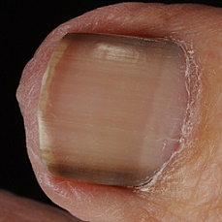  
 check with a GP#595  
**Analysis by this app:**normal = 4%; non-serious = 3%; check with a GP = 93%;   
It is most likely that the nail indicates something that warrants a second opinion and you should seek medical advice. (Confidence score is 93%)×

 check with a GP#345  
**Analysis by this app:**normal = 1%; non-serious = 6%; check with a GP = 93%;   
It is most likely that the nail indicates something that warrants a second opinion and you should seek medical advice. (Confidence score is 93%)×

 check with a GP#405  
**Analysis by this app:**normal = 3%; non-serious = 4%; check with a GP = 93%;   
It is most likely that the nail indicates something that warrants a second opinion and you should seek medical advice. (Confidence score is 93%)×

 check with a GP#380  
**Analysis by this app:**normal = 3%; non-serious = 4%; check with a GP = 93%;   
It is most likely that the nail indicates something that warrants a second opinion and you should seek medical advice. (Confidence score is 93%)×

 check with a GP#510  
**Analysis by this app:**normal = 3%; non-serious = 4%; check with a GP = 93%;   
It is most likely that the nail indicates something that warrants a second opinion and you should seek medical advice. (Confidence score is 93%)×

 check with a GP#445  
**Analysis by this app:**normal = 2%; non-serious = 6%; check with a GP = 92%;   
It is most likely that the nail indicates something that warrants a second opinion and you should seek medical advice. (Confidence score is 92%)×

 check with a GP#500  
**Analysis by this app:**normal = 0%; non-serious = 8%; check with a GP = 92%;   
It is most likely that the nail indicates something that warrants a second opinion and you should seek medical advice. (Confidence score is 92%)×

 check with a GP#210  
**Analysis by this app:**normal = 6%; non-serious = 2%; check with a GP = 91%;   
It is most likely that the nail indicates something that warrants a second opinion and you should seek medical advice. (Confidence score is 91%)×

 check with a GP#185  
**Analysis by this app:**normal = 9%; non-serious = 0%; check with a GP = 91%;   
It is most likely that the nail indicates something that warrants a second opinion and you should seek medical advice. (Confidence score is 91%)×

 check with a GP#370  
**Analysis by this app:**normal = 8%; non-serious = 2%; check with a GP = 90%;   
It is most likely that the nail indicates something that warrants a second opinion and you should seek medical advice. (Confidence score is 90%)×

 check with a GP#505  
**Analysis by this app:**normal = 1%; non-serious = 9%; check with a GP = 90%;   
It is most likely that the nail indicates something that warrants a second opinion and you should seek medical advice. (Confidence score is 90%)×

 check with a GP#410  
**Analysis by this app:**normal = 7%; non-serious = 3%; check with a GP = 90%;   
It is most likely that the nail indicates something that warrants a second opinion and you should seek medical advice. (Confidence score is 90%)×

 check with a GP#280  
**Analysis by this app:**normal = 7%; non-serious = 3%; check with a GP = 90%;   
It is most likely that the nail indicates something that warrants a second opinion and you should seek medical advice. (Confidence score is 90%)×

 check with a GP#490  
**Analysis by this app:**normal = 9%; non-serious = 1%; check with a GP = 89%;   
It is most likely that the nail indicates something that warrants a second opinion and you should seek medical advice. (Confidence score is 89%)×

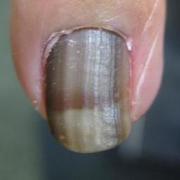  
 check with a GP#650  
**Analysis by this app:**normal = 2%; non-serious = 9%; check with a GP = 89%;   
It is most likely that the nail indicates something that warrants a second opinion and you should seek medical advice. (Confidence score is 89%)×

 check with a GP#150  
**Analysis by this app:**normal = 5%; non-serious = 5%; check with a GP = 89%;   
It is most likely that the nail indicates something that warrants a second opinion and you should seek medical advice. (Confidence score is 89%)×

 check with a GP#315  
**Analysis by this app:**normal = 11%; non-serious = 1%; check with a GP = 88%;   
It is most likely that the nail indicates something that warrants a second opinion and you should seek medical advice. (Confidence score is 88%)×

 check with a GP#120  
**Analysis by this app:**normal = 11%; non-serious = 1%; check with a GP = 88%;   
It is most likely that the nail indicates something that warrants a second opinion and you should seek medical advice. (Confidence score is 88%)×

 check with a GP#305  
**Analysis by this app:**normal = 1%; non-serious = 11%; check with a GP = 88%;   
It is most likely that the nail indicates something that warrants a second opinion and you should seek medical advice. (Confidence score is 88%)×

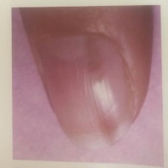  
 check with a GP#740  
**Analysis by this app:**normal = 8%; non-serious = 5%; check with a GP = 88%;   
It is most likely that the nail indicates something that warrants a second opinion and you should seek medical advice. (Confidence score is 88%)×

 check with a GP#165  
**Analysis by this app:**normal = 11%; non-serious = 2%; check with a GP = 87%;   
It is most likely that the nail indicates something that warrants a second opinion and you should seek medical advice. (Confidence score is 87%)×

 check with a GP#385  
**Analysis by this app:**normal = 6%; non-serious = 7%; check with a GP = 87%;   
It is most likely that the nail indicates something that warrants a second opinion and you should seek medical advice. (Confidence score is 87%)×

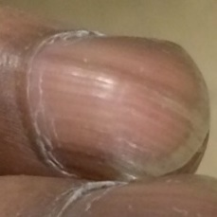  
 check with a GP#565  
**Analysis by this app:**normal = 12%; non-serious = 1%; check with a GP = 87%;   
It is most likely that the nail indicates something that warrants a second opinion and you should seek medical advice. (Confidence score is 87%)×

 check with a GP#435  
**Analysis by this app:**normal = 3%; non-serious = 10%; check with a GP = 86%;   
It is most likely that the nail indicates something that warrants a second opinion and you should seek medical advice. (Confidence score is 86%)×

 check with a GP#295  
**Analysis by this app:**normal = 11%; non-serious = 2%; check with a GP = 86%;   
It is most likely that the nail indicates something that warrants a second opinion and you should seek medical advice. (Confidence score is 86%)×

 check with a GP#290  
**Analysis by this app:**normal = 6%; non-serious = 9%; check with a GP = 85%;   
It is most likely that the nail indicates something that warrants a second opinion and you should seek medical advice. (Confidence score is 85%)×

 check with a GP#160  
**Analysis by this app:**normal = 10%; non-serious = 5%; check with a GP = 84%;   
It is most likely that the nail indicates something that warrants a second opinion and you should seek medical advice. (Confidence score is 84%)×

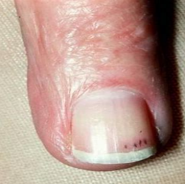  
 check with a GP#725  
**Analysis by this app:**normal = 13%; non-serious = 3%; check with a GP = 84%;   
It is most likely that the nail indicates something that warrants a second opinion and you should seek medical advice. (Confidence score is 84%)×

 check with a GP#415  
**Analysis by this app:**normal = 2%; non-serious = 14%; check with a GP = 83%;   
It is most likely that the nail indicates something that warrants a second opinion and you should seek medical advice. (Confidence score is 83%)×

 check with a GP#20  
**Analysis by this app:**normal = 7%; non-serious = 10%; check with a GP = 83%;   
It is most likely that the nail indicates something that warrants a second opinion and you should seek medical advice. (Confidence score is 83%)×

 check with a GP#335  
**Analysis by this app:**normal = 11%; non-serious = 6%; check with a GP = 83%;   
It is most likely that the nail indicates something that warrants a second opinion and you should seek medical advice. (Confidence score is 83%)×

 check with a GP#340  
**Analysis by this app:**normal = 11%; non-serious = 6%; check with a GP = 83%;   
It is most likely that the nail indicates something that warrants a second opinion and you should seek medical advice. (Confidence score is 83%)×

 check with a GP#300  
**Analysis by this app:**normal = 1%; non-serious = 16%; check with a GP = 82%;   
It is most likely that the nail indicates something that warrants a second opinion and you should seek medical advice. (Confidence score is 82%)×

 check with a GP#225  
**Analysis by this app:**normal = 10%; non-serious = 9%; check with a GP = 80%;   
It is most likely that the nail indicates something that warrants a second opinion and you should seek medical advice. (Confidence score is 80%)×

 check with a GP#80  
**Analysis by this app:**normal = 19%; non-serious = 2%; check with a GP = 80%;   
It is most likely that the nail indicates something that warrants a second opinion and you should seek medical advice. (Confidence score is 80%)×

 check with a GP#430  
**Analysis by this app:**normal = 2%; non-serious = 19%; check with a GP = 79%;   
It is most likely that the nail indicates something that warrants a second opinion and you should seek medical advice. (Confidence score is 79%)×

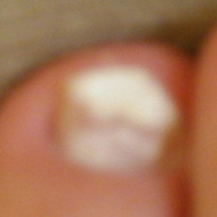  
 check with a GP#670  
**Analysis by this app:**normal = 6%; non-serious = 16%; check with a GP = 78%;   
It is most likely that the nail indicates something that warrants a second opinion and you should seek medical advice. (Confidence score is 78%)×

 check with a GP#450  
**Analysis by this app:**normal = 7%; non-serious = 16%; check with a GP = 77%;   
It is most likely that the nail indicates something that warrants a second opinion and you should seek medical advice. (Confidence score is 77%)×

 check with a GP#285  
**Analysis by this app:**normal = 2%; non-serious = 22%; check with a GP = 77%;   
It is most likely that the nail indicates something that warrants a second opinion and you should seek medical advice. (Confidence score is 77%)×

 check with a GP#60  
**Analysis by this app:**normal = 3%; non-serious = 21%; check with a GP = 76%;   
It is most likely that the nail indicates something that warrants a second opinion and you should seek medical advice. (Confidence score is 76%)×

 check with a GP#35  
**Analysis by this app:**normal = 24%; non-serious = 0%; check with a GP = 75%;   
It is most likely that the nail indicates something that warrants a second opinion and you should seek medical advice. (Confidence score is 75%)×

 check with a GP#460  
**Analysis by this app:**normal = 3%; non-serious = 22%; check with a GP = 75%;   
It is most likely that the nail indicates something that warrants a second opinion and you should seek medical advice. (Confidence score is 75%)×

 check with a GP#100  
**Analysis by this app:**normal = 16%; non-serious = 9%; check with a GP = 75%;   
It is most likely that the nail indicates something that warrants a second opinion and you should seek medical advice. (Confidence score is 75%)×

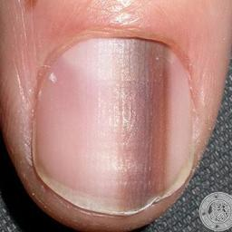  
 check with a GP#665  
**Analysis by this app:**normal = 20%; non-serious = 5%; check with a GP = 75%;   
It is most likely that the nail indicates something that warrants a second opinion and you should seek medical advice. (Confidence score is 75%)×

  
 check with a GP#585  
**Analysis by this app:**normal = 20%; non-serious = 5%; check with a GP = 75%;   
It is most likely that the nail indicates something that warrants a second opinion and you should seek medical advice. (Confidence score is 75%)×

 check with a GP#95  
**Analysis by this app:**normal = 9%; non-serious = 18%; check with a GP = 73%;   
It is most likely that the nail indicates something that warrants a second opinion and you should seek medical advice. (Confidence score is 73%)×

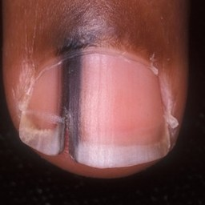  
 check with a GP#640  
**Analysis by this app:**normal = 9%; non-serious = 19%; check with a GP = 72%;   
It is most likely that the nail indicates something that warrants a second opinion and you should seek medical advice. (Confidence score is 72%)×

  
 check with a GP#575  
**Analysis by this app:**normal = 9%; non-serious = 19%; check with a GP = 72%;   
It is most likely that the nail indicates something that warrants a second opinion and you should seek medical advice. (Confidence score is 72%)×

 check with a GP#25  
**Analysis by this app:**normal = 1%; non-serious = 28%; check with a GP = 72%;   
It is most likely that the nail indicates something that warrants a second opinion and you should seek medical advice. (Confidence score is 72%)×

 check with a GP#195  
**Analysis by this app:**normal = 5%; non-serious = 23%; check with a GP = 72%;   
It is most likely that the nail indicates something that warrants a second opinion and you should seek medical advice. (Confidence score is 72%)×

 check with a GP#175  
**Analysis by this app:**normal = 29%; non-serious = 2%; check with a GP = 69%;   
It is most likely that the nail indicates something that warrants a second opinion and you should seek medical advice. (Confidence score is 69%)×

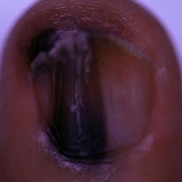  
 check with a GP#660  
**Analysis by this app:**normal = 8%; non-serious = 24%; check with a GP = 68%;   
It is most likely that the nail indicates something that warrants a second opinion and you should seek medical advice. (Confidence score is 68%)×

 check with a GP#420  
**Analysis by this app:**normal = 26%; non-serious = 6%; check with a GP = 68%;   
It is most likely that the nail indicates something that warrants a second opinion and you should seek medical advice. (Confidence score is 68%)×

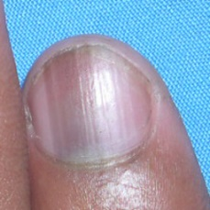  
 check with a GP#535  
**Analysis by this app:**normal = 25%; non-serious = 8%; check with a GP = 67%;   
It is most likely that the nail indicates something that warrants a second opinion and you should seek medical advice. (Confidence score is 67%)×

 check with a GP#485  
**Analysis by this app:**normal = 3%; non-serious = 31%; check with a GP = 66%;   
It is most likely that the nail indicates something that warrants a second opinion and you should seek medical advice. (Confidence score is 66%)×

 check with a GP#520  
**Analysis by this app:**normal = 0%; non-serious = 34%; check with a GP = 66%;   
It is most likely that the nail indicates something that warrants a second opinion and you should seek medical advice. (Confidence score is 66%)×

 check with a GP#155  
**Analysis by this app:**normal = 8%; non-serious = 27%; check with a GP = 65%;   
It is most likely that the nail indicates something that warrants a second opinion and you should seek medical advice. (Confidence score is 65%)×

 check with a GP#180  
**Analysis by this app:**normal = 35%; non-serious = 1%; check with a GP = 64%;   
It is most likely that the nail indicates something that warrants a second opinion and you should seek medical advice. (Confidence score is 64%)×

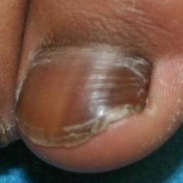  
 check with a GP#555  
**Analysis by this app:**normal = 27%; non-serious = 12%; check with a GP = 61%;   
It is most likely that the nail indicates something that warrants a second opinion and you should seek medical advice. (Confidence score is 61%)×

 check with a GP#265  
**Analysis by this app:**normal = 6%; non-serious = 33%; check with a GP = 61%;   
It is most likely that the nail indicates something that warrants a second opinion and you should seek medical advice. (Confidence score is 61%)×

 check with a GP#355  
**Analysis by this app:**normal = 6%; non-serious = 33%; check with a GP = 60%;   
It is most likely that the nail indicates something that warrants a second opinion and you should seek medical advice. (Confidence score is 60%)×

 check with a GP#325  
**Analysis by this app:**normal = 2%; non-serious = 39%; check with a GP = 60%;   
It is most likely that the nail indicates something that warrants a second opinion and you should seek medical advice. (Confidence score is 60%)×

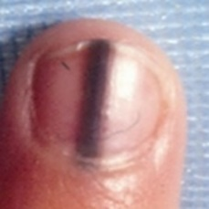  
 check with a GP#550  
**Analysis by this app:**normal = 37%; non-serious = 4%; check with a GP = 59%;   
Not very sure whether the nail is OK or not. Sorry.×

 check with a GP#90  
**Analysis by this app:**normal = 17%; non-serious = 24%; check with a GP = 58%;   
Not very sure whether the nail is OK or not. Sorry.×

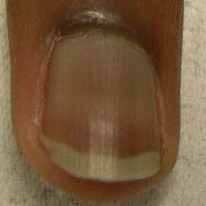  
 check with a GP#540  
**Analysis by this app:**normal = 40%; non-serious = 2%; check with a GP = 58%;   
Not very sure whether the nail is OK or not. Sorry.×

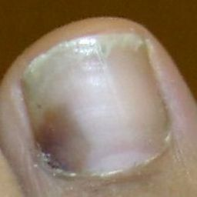  
 check with a GP#630  
**Analysis by this app:**normal = 32%; non-serious = 11%; check with a GP = 57%;   
Not very sure whether the nail is OK or not. Sorry.×

 check with a GP#140  
**Analysis by this app:**normal = 34%; non-serious = 10%; check with a GP = 56%;   
Not very sure whether the nail is OK or not. Sorry.×

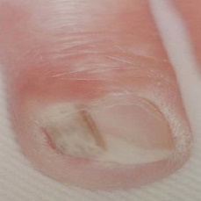  
 check with a GP#750  
**Analysis by this app:**normal = 6%; non-serious = 39%; check with a GP = 56%;   
Not very sure whether the nail is OK or not. Sorry.×

 check with a GP#130  
**Analysis by this app:**normal = 12%; non-serious = 35%; check with a GP = 53%;   
Not very sure whether the nail is OK or not. Sorry.×

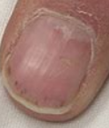  
 check with a GP#715  
**Analysis by this app:**normal = 24%; non-serious = 25%; check with a GP = 51%;   
Not very sure whether the nail is OK or not. Sorry.×

 check with a GP#470  
**Analysis by this app:**normal = 0%; non-serious = 50%; check with a GP = 50%;   
Not very sure whether the nail is OK or not. Sorry.×

 check with a GP#110  
**Analysis by this app:**normal = 0%; non-serious = 51%; check with a GP = 48%;   
Not very sure whether the nail is OK or not. Sorry.×

 check with a GP#495  
**Analysis by this app:**normal = 47%; non-serious = 7%; check with a GP = 46%;   
Not very sure whether the nail is OK or not. Sorry.×

 check with a GP#455  
**Analysis by this app:**normal = 0%; non-serious = 55%; check with a GP = 45%;   
Not very sure whether the nail is OK or not. Sorry.×

 check with a GP#70  
**Analysis by this app:**normal = 56%; non-serious = 0%; check with a GP = 44%;   
Not very sure whether the nail is OK or not. Sorry.×

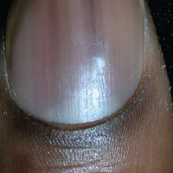  
 check with a GP#635  
**Analysis by this app:**normal = 56%; non-serious = 1%; check with a GP = 42%;   
Not very sure whether the nail is OK or not. Sorry.×

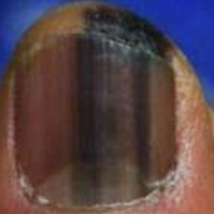  
 check with a GP#680  
**Analysis by this app:**normal = 56%; non-serious = 3%; check with a GP = 41%;   
Not very sure whether the nail is OK or not. Sorry.×

 check with a GP#190  
**Analysis by this app:**normal = 58%; non-serious = 1%; check with a GP = 41%;   
Not very sure whether the nail is OK or not. Sorry.×

 check with a GP#440  
**Analysis by this app:**normal = 0%; non-serious = 61%; check with a GP = 39%;   
Perhaps a GP should be consulted (confidence score is 39%) ×

 check with a GP#15  
**Analysis by this app:**normal = 60%; non-serious = 1%; check with a GP = 39%;   
Perhaps a GP should be consulted (confidence score is 39%) ×

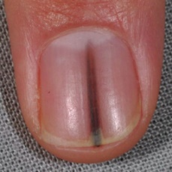  
 check with a GP#570  
**Analysis by this app:**normal = 62%; non-serious = 0%; check with a GP = 38%;   
Perhaps a GP should be consulted (confidence score is 38%) ×

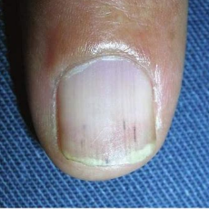  
 check with a GP#720  
**Analysis by this app:**normal = 54%; non-serious = 8%; check with a GP = 38%;   
Not very sure whether the nail is OK or not. Sorry.×

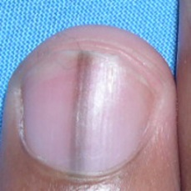  
 check with a GP#610  
**Analysis by this app:**normal = 63%; non-serious = 1%; check with a GP = 37%;   
Perhaps a GP should be consulted (confidence score is 37%) ×

 check with a GP#320  
**Analysis by this app:**normal = 1%; non-serious = 63%; check with a GP = 36%;   
Perhaps a GP should be consulted (confidence score is 36%) ×

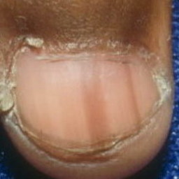  
 check with a GP#530  
**Analysis by this app:**normal = 50%; non-serious = 15%; check with a GP = 36%;   
Not very sure whether the nail is OK or not. Sorry.×

 check with a GP#105  
**Analysis by this app:**normal = 65%; non-serious = 1%; check with a GP = 34%;   
Perhaps a GP should be consulted (confidence score is 34%) ×

 check with a GP#55  
**Analysis by this app:**normal = 74%; non-serious = 0%; check with a GP = 26%;   
Perhaps a GP should be consulted (confidence score is 26%) ×

 check with a GP#245  
**Analysis by this app:**normal = 68%; non-serious = 7%; check with a GP = 26%;   
Perhaps a GP should be consulted (confidence score is 26%) ×

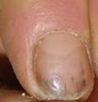  
 check with a GP#695  
**Analysis by this app:**normal = 17%; non-serious = 62%; check with a GP = 21%;   
Perhaps a GP should be consulted (confidence score is 21%) ×

 check with a GP#30  
**Analysis by this app:**normal = 73%; non-serious = 6%; check with a GP = 21%;   
Perhaps a GP should be consulted (confidence score is 21%) ×

 check with a GP#115  
**Analysis by this app:**normal = 78%; non-serious = 2%; check with a GP = 20%;   
Perhaps a GP should be consulted (confidence score is 20%) ×

 check with a GP#125  
**Analysis by this app:**normal = 80%; non-serious = 0%; check with a GP = 19%;   
The nail's condition is normal with confidence score of 80%.  
The confidence score for consulting a GP is 19%.×

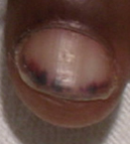  
 check with a GP#705  
**Analysis by this app:**normal = 7%; non-serious = 73%; check with a GP = 19%;   
The nail's condition is non-serious with confidence score of 73%.  
The confidence score for consulting a GP is 19%.×

 check with a GP#170  
**Analysis by this app:**normal = 83%; non-serious = 2%; check with a GP = 15%;   
The nail's condition is normal with confidence score of 83%.  
The confidence score for consulting a GP is 15%.×

 check with a GP#250  
**Analysis by this app:**normal = 85%; non-serious = 1%; check with a GP = 14%;   
The nail's condition is normal with confidence score of 85%.  
The confidence score for consulting a GP is 14%.×

 check with a GP#375  
**Analysis by this app:**normal = 6%; non-serious = 80%; check with a GP = 14%;   
The nail's condition is non-serious with confidence score of 80%.  
The confidence score for consulting a GP is 14%.×

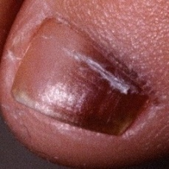  
 check with a GP#605  
**Analysis by this app:**normal = 7%; non-serious = 80%; check with a GP = 14%;   
The nail's condition is non-serious with confidence score of 80%.  
The confidence score for consulting a GP is 14%.×

 check with a GP#205  
**Analysis by this app:**normal = 4%; non-serious = 82%; check with a GP = 14%;   
The nail's condition is non-serious with confidence score of 82%.  
The confidence score for consulting a GP is 14%.×

 check with a GP#255  
**Analysis by this app:**normal = 81%; non-serious = 6%; check with a GP = 13%;   
The nail's condition is normal with confidence score of 81%.  
The confidence score for consulting a GP is 13%.×

 check with a GP#45  
**Analysis by this app:**normal = 88%; non-serious = 0%; check with a GP = 11%;   
The nail's condition is normal with confidence score of 88%.  
The confidence score for consulting a GP is 11%.×

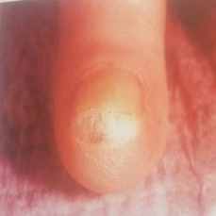  
 check with a GP#735  
**Analysis by this app:**normal = 73%; non-serious = 17%; check with a GP = 10%;   
The nail's condition is normal with confidence score of 73%.  
Otherwise it is non-serious with confidence score of 17%.×

 check with a GP#5  
**Analysis by this app:**normal = 90%; non-serious = 1%; check with a GP = 9%;   
The nail's condition is normal with confidence score of 90%.  
The confidence score for consulting a GP is 9%.×

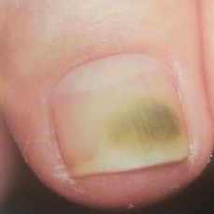  
 check with a GP#755  
**Analysis by this app:**normal = 88%; non-serious = 4%; check with a GP = 8%;   
The nail's condition is normal with confidence score of 88%.  
The confidence score for consulting a GP is 8%.×

 check with a GP#75  
**Analysis by this app:**normal = 93%; non-serious = 0%; check with a GP = 7%;   
The nail's condition is normal with confidence score of 93%.  
The confidence score for consulting a GP is 7%.×

 check with a GP#85  
**Analysis by this app:**normal = 0%; non-serious = 93%; check with a GP = 7%;   
The nail's condition is non-serious with confidence score of 93%.  
The confidence score for consulting a GP is 7%.×

 check with a GP#0  
**Analysis by this app:**normal = 0%; non-serious = 94%; check with a GP = 6%;   
The nail's condition is non-serious with confidence score of 94%.  
The confidence score for consulting a GP is 6%.×

 check with a GP#40  
**Analysis by this app:**normal = 90%; non-serious = 5%; check with a GP = 6%;   
The nail's condition is normal with confidence score of 90%.  
The confidence score for consulting a GP is 6%.×

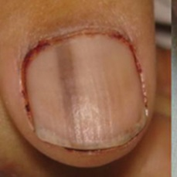  
 check with a GP#620  
**Analysis by this app:**normal = 77%; non-serious = 19%; check with a GP = 4%;   
The nail's condition is normal with confidence score of 77%.  
Otherwise it is non-serious with confidence score of 19%.×

 check with a GP#480  
**Analysis by this app:**normal = 0%; non-serious = 97%; check with a GP = 2%;   
The nail's condition is non-serious with confidence score of 97%.  
The confidence score for consulting a GP is 2%.×

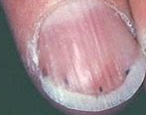  
 check with a GP#710  
**Analysis by this app:**normal = 17%; non-serious = 82%; check with a GP = 2%;   
The nail's condition is non-serious with confidence score of 82%.  
Otherwise it is normal with confidence score of 17%.×

 check with a GP#50  
**Analysis by this app:**normal = 98%; non-serious = 0%; check with a GP = 1%;   
The nail's condition is normal with confidence score of 98%.  
The confidence score for consulting a GP is 1%.×

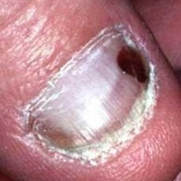  
 check with a GP#655  
**Analysis by this app:**normal = 0%; non-serious = 99%; check with a GP = 1%;   
The nail's condition is non-serious with confidence score of 99%.  
The confidence score for consulting a GP is 1%.×

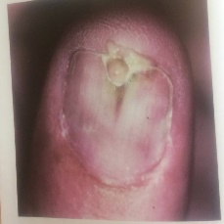  
 check with a GP#760  
**Analysis by this app:**normal = 0%; non-serious = 100%; check with a GP = 0%;   
The nail's condition is non-serious with confidence score of 100%.×

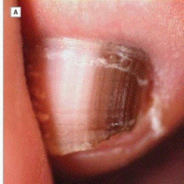  
 check with a GP#625  
**Analysis by this app:**normal = 0%; non-serious = 100%; check with a GP = 0%;   
The nail's condition is non-serious with confidence score of 100%.×

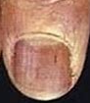  
 check with a GP#700  
**Analysis by this app:**normal = 0%; non-serious = 100%; check with a GP = 0%;   
The nail's condition is non-serious with confidence score of 100%.×

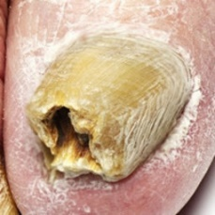  
 non-serious#1605  
**Analysis by this app:**normal = 0%; non-serious = 100%; check with a GP = 0%;   
The nail's condition is non-serious with confidence score of 100%.×

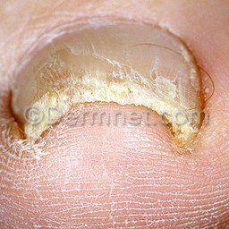  
 non-serious#1190  
**Analysis by this app:**normal = 0%; non-serious = 100%; check with a GP = 0%;   
The nail's condition is non-serious with confidence score of 100%.×

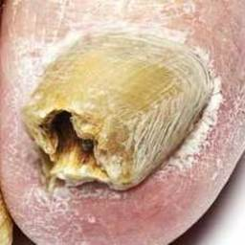  
 non-serious#1015  
**Analysis by this app:**normal = 0%; non-serious = 100%; check with a GP = 0%;   
The nail's condition is non-serious with confidence score of 100%.×

 non-serious#120  
**Analysis by this app:**normal = 0%; non-serious = 100%; check with a GP = 0%;   
The nail's condition is non-serious with confidence score of 100%.×

 non-serious#705  
**Analysis by this app:**normal = 0%; non-serious = 100%; check with a GP = 0%;   
The nail's condition is non-serious with confidence score of 100%.×

 non-serious#660  
**Analysis by this app:**normal = 0%; non-serious = 100%; check with a GP = 0%;   
The nail's condition is non-serious with confidence score of 100%.×

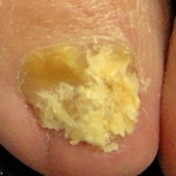  
 non-serious#1060  
**Analysis by this app:**normal = 0%; non-serious = 100%; check with a GP = 0%;   
The nail's condition is non-serious with confidence score of 100%.×

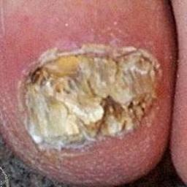  
 non-serious#1220  
**Analysis by this app:**normal = 0%; non-serious = 100%; check with a GP = 0%;   
The nail's condition is non-serious with confidence score of 100%.×

 non-serious#490  
**Analysis by this app:**normal = 0%; non-serious = 100%; check with a GP = 0%;   
The nail's condition is non-serious with confidence score of 100%.×

 non-serious#855  
**Analysis by this app:**normal = 0%; non-serious = 100%; check with a GP = 0%;   
The nail's condition is non-serious with confidence score of 100%.×

 non-serious#690  
**Analysis by this app:**normal = 0%; non-serious = 100%; check with a GP = 0%;   
The nail's condition is non-serious with confidence score of 100%.×

 non-serious#665  
**Analysis by this app:**normal = 0%; non-serious = 100%; check with a GP = 0%;   
The nail's condition is non-serious with confidence score of 100%.×

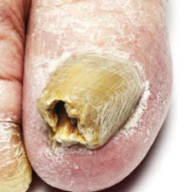  
 non-serious#1425  
**Analysis by this app:**normal = 0%; non-serious = 100%; check with a GP = 0%;   
The nail's condition is non-serious with confidence score of 100%.×

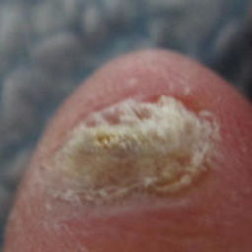  
 non-serious#1535  
**Analysis by this app:**normal = 0%; non-serious = 100%; check with a GP = 0%;   
The nail's condition is non-serious with confidence score of 100%.×

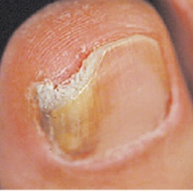  
 non-serious#1520  
**Analysis by this app:**normal = 0%; non-serious = 100%; check with a GP = 0%;   
The nail's condition is non-serious with confidence score of 100%.×

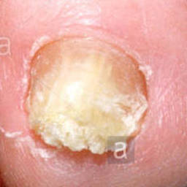  
 non-serious#1055  
**Analysis by this app:**normal = 0%; non-serious = 100%; check with a GP = 0%;   
The nail's condition is non-serious with confidence score of 100%.×

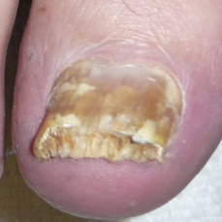  
 non-serious#1240  
**Analysis by this app:**normal = 0%; non-serious = 100%; check with a GP = 0%;   
The nail's condition is non-serious with confidence score of 100%.×

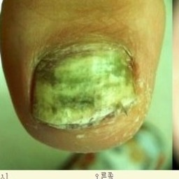  
 non-serious#1550  
**Analysis by this app:**normal = 0%; non-serious = 100%; check with a GP = 0%;   
The nail's condition is non-serious with confidence score of 100%.×

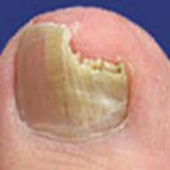  
 non-serious#1215  
**Analysis by this app:**normal = 0%; non-serious = 100%; check with a GP = 0%;   
The nail's condition is non-serious with confidence score of 100%.×

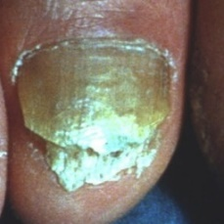  
 non-serious#1260  
**Analysis by this app:**normal = 0%; non-serious = 100%; check with a GP = 0%;   
The nail's condition is non-serious with confidence score of 100%.×

 non-serious#135  
**Analysis by this app:**normal = 0%; non-serious = 100%; check with a GP = 0%;   
The nail's condition is non-serious with confidence score of 100%.×

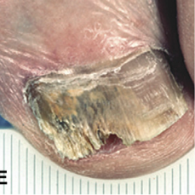  
 non-serious#1645  
**Analysis by this app:**normal = 0%; non-serious = 100%; check with a GP = 0%;   
The nail's condition is non-serious with confidence score of 100%.×

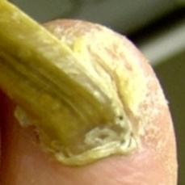  
 non-serious#1335  
**Analysis by this app:**normal = 0%; non-serious = 100%; check with a GP = 0%;   
The nail's condition is non-serious with confidence score of 100%.×

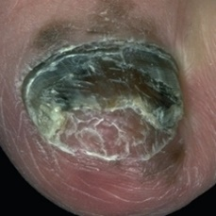  
 non-serious#1465  
**Analysis by this app:**normal = 0%; non-serious = 100%; check with a GP = 0%;   
The nail's condition is non-serious with confidence score of 100%.×

 non-serious#645  
**Analysis by this app:**normal = 0%; non-serious = 100%; check with a GP = 0%;   
The nail's condition is non-serious with confidence score of 100%.×

 non-serious#270  
**Analysis by this app:**normal = 0%; non-serious = 100%; check with a GP = 0%;   
The nail's condition is non-serious with confidence score of 100%.×

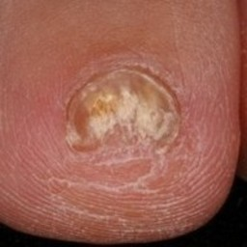  
 non-serious#1505  
**Analysis by this app:**normal = 0%; non-serious = 100%; check with a GP = 0%;   
The nail's condition is non-serious with confidence score of 100%.×

 non-serious#355  
**Analysis by this app:**normal = 0%; non-serious = 100%; check with a GP = 0%;   
The nail's condition is non-serious with confidence score of 100%.×

 non-serious#75  
**Analysis by this app:**normal = 0%; non-serious = 100%; check with a GP = 0%;   
The nail's condition is non-serious with confidence score of 100%.×

 non-serious#395  
**Analysis by this app:**normal = 0%; non-serious = 100%; check with a GP = 0%;   
The nail's condition is non-serious with confidence score of 100%.×

 non-serious#115  
**Analysis by this app:**normal = 0%; non-serious = 100%; check with a GP = 0%;   
The nail's condition is non-serious with confidence score of 100%.×

 non-serious#205  
**Analysis by this app:**normal = 0%; non-serious = 100%; check with a GP = 0%;   
The nail's condition is non-serious with confidence score of 100%.×

 non-serious#860  
**Analysis by this app:**normal = 0%; non-serious = 100%; check with a GP = 0%;   
The nail's condition is non-serious with confidence score of 100%.×

 non-serious#950  
**Analysis by this app:**normal = 0%; non-serious = 100%; check with a GP = 0%;   
The nail's condition is non-serious with confidence score of 100%.×

 non-serious#130  
**Analysis by this app:**normal = 0%; non-serious = 100%; check with a GP = 0%;   
The nail's condition is non-serious with confidence score of 100%.×

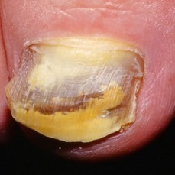  
 non-serious#1250  
**Analysis by this app:**normal = 0%; non-serious = 100%; check with a GP = 0%;   
The nail's condition is non-serious with confidence score of 100%.×

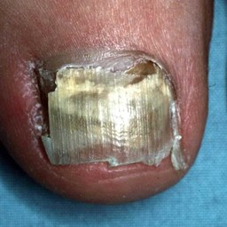  
 non-serious#1350  
**Analysis by this app:**normal = 0%; non-serious = 100%; check with a GP = 0%;   
The nail's condition is non-serious with confidence score of 100%.×

 non-serious#465  
**Analysis by this app:**normal = 0%; non-serious = 100%; check with a GP = 0%;   
The nail's condition is non-serious with confidence score of 100%.×

 non-serious#675  
**Analysis by this app:**normal = 0%; non-serious = 100%; check with a GP = 0%;   
The nail's condition is non-serious with confidence score of 100%.×

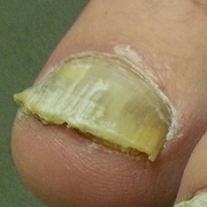  
 non-serious#1285  
**Analysis by this app:**normal = 0%; non-serious = 100%; check with a GP = 0%;   
The nail's condition is non-serious with confidence score of 100%.×

 non-serious#940  
**Analysis by this app:**normal = 0%; non-serious = 100%; check with a GP = 0%;   
The nail's condition is non-serious with confidence score of 100%.×

 non-serious#975  
**Analysis by this app:**normal = 0%; non-serious = 100%; check with a GP = 0%;   
The nail's condition is non-serious with confidence score of 100%.×

 non-serious#760  
**Analysis by this app:**normal = 0%; non-serious = 100%; check with a GP = 0%;   
The nail's condition is non-serious with confidence score of 100%.×

 non-serious#720  
**Analysis by this app:**normal = 0%; non-serious = 100%; check with a GP = 0%;   
The nail's condition is non-serious with confidence score of 100%.×

 non-serious#220  
**Analysis by this app:**normal = 0%; non-serious = 100%; check with a GP = 0%;   
The nail's condition is non-serious with confidence score of 100%.×

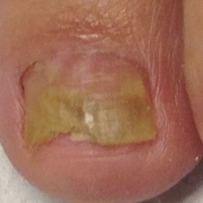  
 non-serious#1100  
**Analysis by this app:**normal = 0%; non-serious = 100%; check with a GP = 0%;   
The nail's condition is non-serious with confidence score of 100%.×

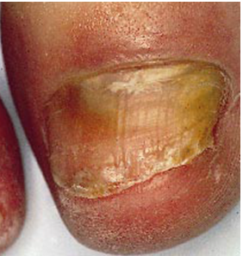  
 non-serious#1615  
**Analysis by this app:**normal = 0%; non-serious = 100%; check with a GP = 0%;   
The nail's condition is non-serious with confidence score of 100%.×

 non-serious#470  
**Analysis by this app:**normal = 0%; non-serious = 100%; check with a GP = 0%;   
The nail's condition is non-serious with confidence score of 100%.×

 non-serious#740  
**Analysis by this app:**normal = 0%; non-serious = 100%; check with a GP = 0%;   
The nail's condition is non-serious with confidence score of 100%.×

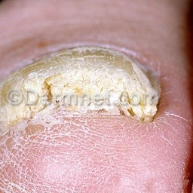  
 non-serious#1050  
**Analysis by this app:**normal = 0%; non-serious = 100%; check with a GP = 0%;   
The nail's condition is non-serious with confidence score of 100%.×

 non-serious#655  
**Analysis by this app:**normal = 0%; non-serious = 100%; check with a GP = 0%;   
The nail's condition is non-serious with confidence score of 100%.×

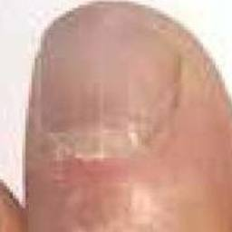  
 non-serious#1245  
**Analysis by this app:**normal = 0%; non-serious = 100%; check with a GP = 0%;   
The nail's condition is non-serious with confidence score of 100%.×

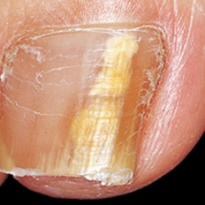  
 non-serious#1500  
**Analysis by this app:**normal = 0%; non-serious = 100%; check with a GP = 0%;   
The nail's condition is non-serious with confidence score of 100%.×

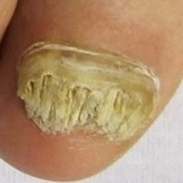  
 non-serious#1120  
**Analysis by this app:**normal = 0%; non-serious = 100%; check with a GP = 0%;   
The nail's condition is non-serious with confidence score of 100%.×

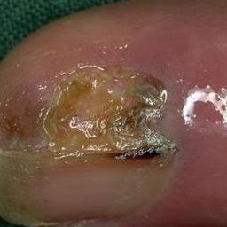  
 non-serious#1495  
**Analysis by this app:**normal = 0%; non-serious = 100%; check with a GP = 0%;   
The nail's condition is non-serious with confidence score of 100%.×

 non-serious#405  
**Analysis by this app:**normal = 0%; non-serious = 100%; check with a GP = 0%;   
The nail's condition is non-serious with confidence score of 100%.×

 non-serious#125  
**Analysis by this app:**normal = 0%; non-serious = 100%; check with a GP = 0%;   
The nail's condition is non-serious with confidence score of 100%.×

 non-serious#80  
**Analysis by this app:**normal = 0%; non-serious = 100%; check with a GP = 0%;   
The nail's condition is non-serious with confidence score of 100%.×

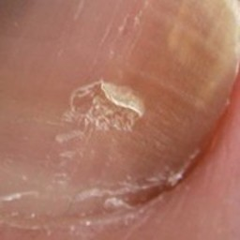  
 non-serious#1275  
**Analysis by this app:**normal = 0%; non-serious = 100%; check with a GP = 0%;   
The nail's condition is non-serious with confidence score of 100%.×

 non-serious#885  
**Analysis by this app:**normal = 0%; non-serious = 100%; check with a GP = 0%;   
The nail's condition is non-serious with confidence score of 100%.×

 non-serious#575  
**Analysis by this app:**normal = 0%; non-serious = 100%; check with a GP = 0%;   
The nail's condition is non-serious with confidence score of 100%.×

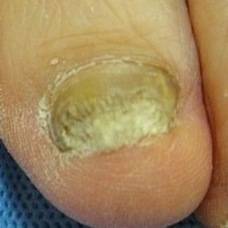  
 non-serious#1600  
**Analysis by this app:**normal = 0%; non-serious = 100%; check with a GP = 0%;   
The nail's condition is non-serious with confidence score of 100%.×

 non-serious#485  
**Analysis by this app:**normal = 0%; non-serious = 100%; check with a GP = 0%;   
The nail's condition is non-serious with confidence score of 100%.×

 non-serious#10  
**Analysis by this app:**normal = 0%; non-serious = 100%; check with a GP = 0%;   
The nail's condition is non-serious with confidence score of 100%.×

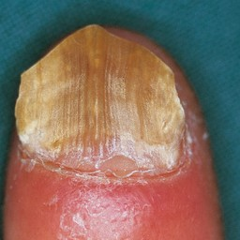  
 non-serious#1375  
**Analysis by this app:**normal = 0%; non-serious = 100%; check with a GP = 0%;   
The nail's condition is non-serious with confidence score of 100%.×

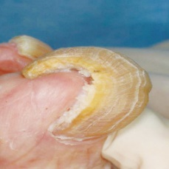  
 non-serious#1540  
**Analysis by this app:**normal = 0%; non-serious = 100%; check with a GP = 0%;   
The nail's condition is non-serious with confidence score of 100%.×

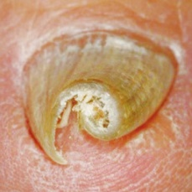  
 non-serious#1485  
**Analysis by this app:**normal = 0%; non-serious = 100%; check with a GP = 0%;   
The nail's condition is non-serious with confidence score of 100%.×

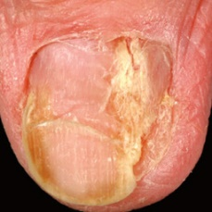  
 non-serious#1255  
**Analysis by this app:**normal = 0%; non-serious = 100%; check with a GP = 0%;   
The nail's condition is non-serious with confidence score of 100%.×

 non-serious#590  
**Analysis by this app:**normal = 0%; non-serious = 100%; check with a GP = 0%;   
The nail's condition is non-serious with confidence score of 100%.×

 non-serious#935  
**Analysis by this app:**normal = 0%; non-serious = 100%; check with a GP = 0%;   
The nail's condition is non-serious with confidence score of 100%.×

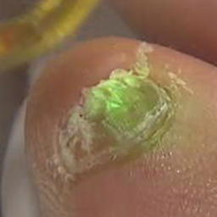  
 non-serious#1585  
**Analysis by this app:**normal = 0%; non-serious = 100%; check with a GP = 0%;   
The nail's condition is non-serious with confidence score of 100%.×

  
 non-serious#1545  
**Analysis by this app:**normal = 0%; non-serious = 100%; check with a GP = 0%;   
The nail's condition is non-serious with confidence score of 100%.×

 non-serious#840  
**Analysis by this app:**normal = 0%; non-serious = 100%; check with a GP = 0%;   
The nail's condition is non-serious with confidence score of 100%.×

 non-serious#630  
**Analysis by this app:**normal = 0%; non-serious = 100%; check with a GP = 0%;   
The nail's condition is non-serious with confidence score of 100%.×

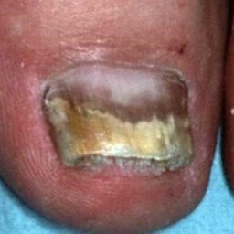  
 non-serious#1210  
**Analysis by this app:**normal = 0%; non-serious = 100%; check with a GP = 0%;   
The nail's condition is non-serious with confidence score of 100%.×

 non-serious#50  
**Analysis by this app:**normal = 0%; non-serious = 100%; check with a GP = 0%;   
The nail's condition is non-serious with confidence score of 100%.×

 non-serious#965  
**Analysis by this app:**normal = 0%; non-serious = 100%; check with a GP = 0%;   
The nail's condition is non-serious with confidence score of 100%.×

 non-serious#745  
**Analysis by this app:**normal = 0%; non-serious = 100%; check with a GP = 0%;   
The nail's condition is non-serious with confidence score of 100%.×

 non-serious#830  
**Analysis by this app:**normal = 0%; non-serious = 100%; check with a GP = 0%;   
The nail's condition is non-serious with confidence score of 100%.×

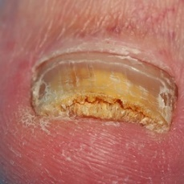  
 non-serious#1380  
**Analysis by this app:**normal = 0%; non-serious = 100%; check with a GP = 0%;   
The nail's condition is non-serious with confidence score of 100%.×

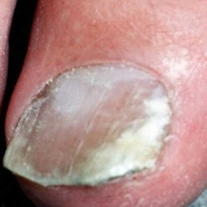  
 non-serious#1360  
**Analysis by this app:**normal = 0%; non-serious = 100%; check with a GP = 0%;   
The nail's condition is non-serious with confidence score of 100%.×

 non-serious#235  
**Analysis by this app:**normal = 0%; non-serious = 100%; check with a GP = 0%;   
The nail's condition is non-serious with confidence score of 100%.×

 non-serious#160  
**Analysis by this app:**normal = 0%; non-serious = 100%; check with a GP = 0%;   
The nail's condition is non-serious with confidence score of 100%.×

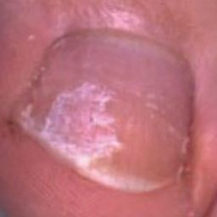  
 non-serious#1280  
**Analysis by this app:**normal = 0%; non-serious = 100%; check with a GP = 0%;   
The nail's condition is non-serious with confidence score of 100%.×

  
 non-serious#1075  
**Analysis by this app:**normal = 0%; non-serious = 100%; check with a GP = 0%;   
The nail's condition is non-serious with confidence score of 100%.×

 non-serious#870  
**Analysis by this app:**normal = 0%; non-serious = 100%; check with a GP = 0%;   
The nail's condition is non-serious with confidence score of 100%.×

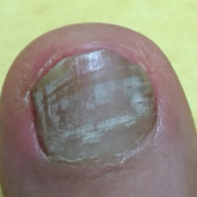  
 non-serious#1575  
**Analysis by this app:**normal = 0%; non-serious = 100%; check with a GP = 0%;   
The nail's condition is non-serious with confidence score of 100%.×

 non-serious#595  
**Analysis by this app:**normal = 0%; non-serious = 100%; check with a GP = 0%;   
The nail's condition is non-serious with confidence score of 100%.×

 non-serious#680  
**Analysis by this app:**normal = 0%; non-serious = 100%; check with a GP = 0%;   
The nail's condition is non-serious with confidence score of 100%.×

 non-serious#200  
**Analysis by this app:**normal = 0%; non-serious = 100%; check with a GP = 0%;   
The nail's condition is non-serious with confidence score of 100%.×

 non-serious#390  
**Analysis by this app:**normal = 0%; non-serious = 100%; check with a GP = 0%;   
The nail's condition is non-serious with confidence score of 100%.×

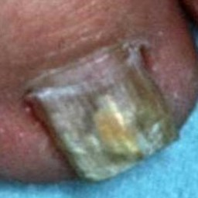  
 non-serious#1175  
**Analysis by this app:**normal = 0%; non-serious = 100%; check with a GP = 0%;   
The nail's condition is non-serious with confidence score of 100%.×

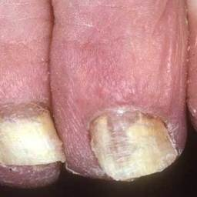  
 non-serious#1450  
**Analysis by this app:**normal = 0%; non-serious = 100%; check with a GP = 0%;   
The nail's condition is non-serious with confidence score of 100%.×

 non-serious#1000  
**Analysis by this app:**normal = 0%; non-serious = 100%; check with a GP = 0%;   
The nail's condition is non-serious with confidence score of 100%.×

 non-serious#95  
**Analysis by this app:**normal = 0%; non-serious = 100%; check with a GP = 0%;   
The nail's condition is non-serious with confidence score of 100%.×

 non-serious#990  
**Analysis by this app:**normal = 0%; non-serious = 100%; check with a GP = 0%;   
The nail's condition is non-serious with confidence score of 100%.×

 non-serious#670  
**Analysis by this app:**normal = 0%; non-serious = 100%; check with a GP = 0%;   
The nail's condition is non-serious with confidence score of 100%.×

 non-serious#930  
**Analysis by this app:**normal = 0%; non-serious = 100%; check with a GP = 0%;   
The nail's condition is non-serious with confidence score of 100%.×

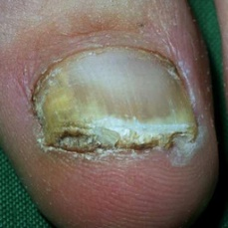  
 non-serious#1480  
**Analysis by this app:**normal = 0%; non-serious = 100%; check with a GP = 0%;   
The nail's condition is non-serious with confidence score of 100%.×

 non-serious#780  
**Analysis by this app:**normal = 0%; non-serious = 100%; check with a GP = 0%;   
The nail's condition is non-serious with confidence score of 100%.×

 non-serious#895  
**Analysis by this app:**normal = 0%; non-serious = 100%; check with a GP = 0%;   
The nail's condition is non-serious with confidence score of 100%.×

 non-serious#580  
**Analysis by this app:**normal = 0%; non-serious = 100%; check with a GP = 0%;   
The nail's condition is non-serious with confidence score of 100%.×

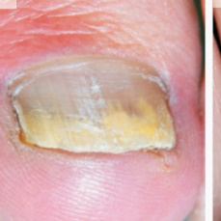  
 non-serious#1610  
**Analysis by this app:**normal = 0%; non-serious = 100%; check with a GP = 0%;   
The nail's condition is non-serious with confidence score of 100%.×

 non-serious#245  
**Analysis by this app:**normal = 0%; non-serious = 100%; check with a GP = 0%;   
The nail's condition is non-serious with confidence score of 100%.×

 non-serious#310  
**Analysis by this app:**normal = 0%; non-serious = 100%; check with a GP = 0%;   
The nail's condition is non-serious with confidence score of 100%.×

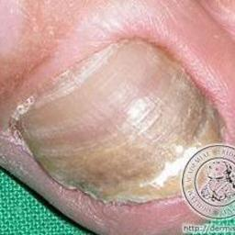  
 non-serious#1160  
**Analysis by this app:**normal = 0%; non-serious = 100%; check with a GP = 0%;   
The nail's condition is non-serious with confidence score of 100%.×

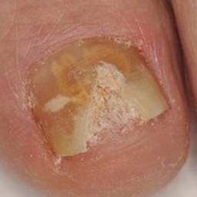  
 non-serious#1365  
**Analysis by this app:**normal = 0%; non-serious = 100%; check with a GP = 0%;   
The nail's condition is non-serious with confidence score of 100%.×

 non-serious#100  
**Analysis by this app:**normal = 0%; non-serious = 100%; check with a GP = 0%;   
The nail's condition is non-serious with confidence score of 100%.×

 non-serious#480  
**Analysis by this app:**normal = 0%; non-serious = 100%; check with a GP = 0%;   
The nail's condition is non-serious with confidence score of 100%.×

 non-serious#970  
**Analysis by this app:**normal = 0%; non-serious = 100%; check with a GP = 0%;   
The nail's condition is non-serious with confidence score of 100%.×

 non-serious#865  
**Analysis by this app:**normal = 0%; non-serious = 100%; check with a GP = 0%;   
The nail's condition is non-serious with confidence score of 100%.×

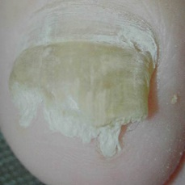  
 non-serious#1525  
**Analysis by this app:**normal = 0%; non-serious = 100%; check with a GP = 0%;   
The nail's condition is non-serious with confidence score of 100%.×

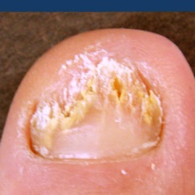  
 non-serious#1155  
**Analysis by this app:**normal = 0%; non-serious = 100%; check with a GP = 0%;   
The nail's condition is non-serious with confidence score of 100%.×

 non-serious#45  
**Analysis by this app:**normal = 0%; non-serious = 100%; check with a GP = 0%;   
The nail's condition is non-serious with confidence score of 100%.×

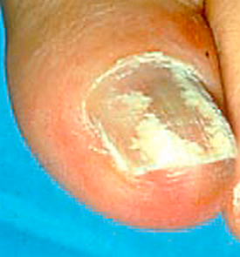  
 non-serious#1620  
**Analysis by this app:**normal = 0%; non-serious = 100%; check with a GP = 0%;   
The nail's condition is non-serious with confidence score of 100%.×

 non-serious#640  
**Analysis by this app:**normal = 0%; non-serious = 100%; check with a GP = 0%;   
The nail's condition is non-serious with confidence score of 100%.×

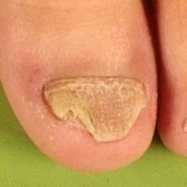  
 non-serious#1270  
**Analysis by this app:**normal = 0%; non-serious = 100%; check with a GP = 0%;   
The nail's condition is non-serious with confidence score of 100%.×

 non-serious#850  
**Analysis by this app:**normal = 0%; non-serious = 100%; check with a GP = 0%;   
The nail's condition is non-serious with confidence score of 100%.×

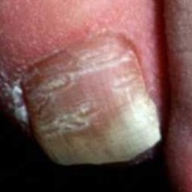  
 non-serious#1180  
**Analysis by this app:**normal = 0%; non-serious = 100%; check with a GP = 0%;   
The nail's condition is non-serious with confidence score of 100%.×

 non-serious#750  
**Analysis by this app:**normal = 0%; non-serious = 100%; check with a GP = 0%;   
The nail's condition is non-serious with confidence score of 100%.×

 non-serious#90  
**Analysis by this app:**normal = 0%; non-serious = 100%; check with a GP = 0%;   
The nail's condition is non-serious with confidence score of 100%.×

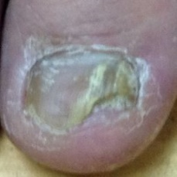  
 non-serious#1470  
**Analysis by this app:**normal = 0%; non-serious = 100%; check with a GP = 0%;   
The nail's condition is non-serious with confidence score of 100%.×

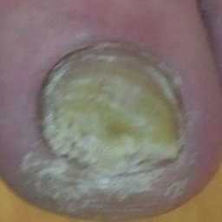  
 non-serious#1345  
**Analysis by this app:**normal = 0%; non-serious = 100%; check with a GP = 0%;   
The nail's condition is non-serious with confidence score of 100%.×

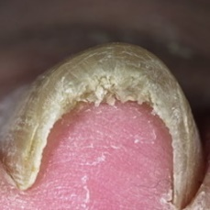  
 non-serious#1440  
**Analysis by this app:**normal = 0%; non-serious = 99%; check with a GP = 0%;   
The nail's condition is non-serious with confidence score of 99%.×

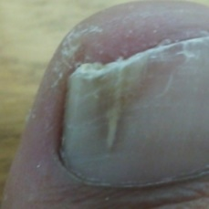  
 non-serious#1515  
**Analysis by this app:**normal = 0%; non-serious = 99%; check with a GP = 0%;   
The nail's condition is non-serious with confidence score of 99%.×

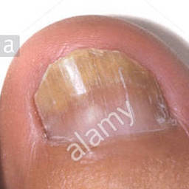  
 non-serious#1115  
**Analysis by this app:**normal = 0%; non-serious = 99%; check with a GP = 0%;   
The nail's condition is non-serious with confidence score of 99%.×

 non-serious#300  
**Analysis by this app:**normal = 0%; non-serious = 99%; check with a GP = 0%;   
The nail's condition is non-serious with confidence score of 99%.×

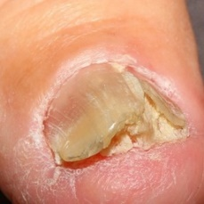  
 non-serious#1040  
**Analysis by this app:**normal = 0%; non-serious = 99%; check with a GP = 0%;   
The nail's condition is non-serious with confidence score of 99%.×

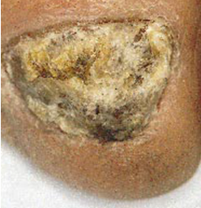  
 non-serious#1625  
**Analysis by this app:**normal = 0%; non-serious = 99%; check with a GP = 1%;   
The nail's condition is non-serious with confidence score of 99%.  
The confidence score for consulting a GP is 1%.×

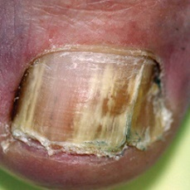  
 non-serious#1235  
**Analysis by this app:**normal = 0%; non-serious = 99%; check with a GP = 1%;   
The nail's condition is non-serious with confidence score of 99%.  
The confidence score for consulting a GP is 1%.×

 non-serious#185  
**Analysis by this app:**normal = 0%; non-serious = 99%; check with a GP = 1%;   
The nail's condition is non-serious with confidence score of 99%.  
The confidence score for consulting a GP is 1%.×

 non-serious#65  
**Analysis by this app:**normal = 0%; non-serious = 99%; check with a GP = 0%;   
The nail's condition is non-serious with confidence score of 99%.×

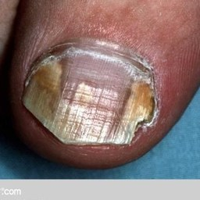  
 non-serious#1325  
**Analysis by this app:**normal = 0%; non-serious = 99%; check with a GP = 1%;   
The nail's condition is non-serious with confidence score of 99%.  
The confidence score for consulting a GP is 1%.×

 non-serious#145  
**Analysis by this app:**normal = 0%; non-serious = 99%; check with a GP = 0%;   
The nail's condition is non-serious with confidence score of 99%.×

 non-serious#140  
**Analysis by this app:**normal = 0%; non-serious = 99%; check with a GP = 1%;   
The nail's condition is non-serious with confidence score of 99%.  
The confidence score for consulting a GP is 1%.×

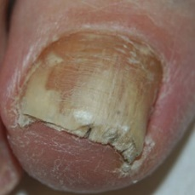  
 non-serious#1200  
**Analysis by this app:**normal = 0%; non-serious = 99%; check with a GP = 1%;   
The nail's condition is non-serious with confidence score of 99%.  
The confidence score for consulting a GP is 1%.×

 non-serious#800  
**Analysis by this app:**normal = 0%; non-serious = 99%; check with a GP = 1%;   
The nail's condition is non-serious with confidence score of 99%.  
The confidence score for consulting a GP is 1%.×

 non-serious#880  
**Analysis by this app:**normal = 0%; non-serious = 99%; check with a GP = 1%;   
The nail's condition is non-serious with confidence score of 99%.  
The confidence score for consulting a GP is 1%.×

 non-serious#845  
**Analysis by this app:**normal = 0%; non-serious = 99%; check with a GP = 1%;   
The nail's condition is non-serious with confidence score of 99%.  
The confidence score for consulting a GP is 1%.×

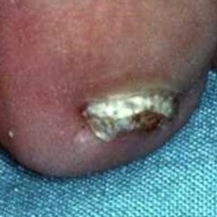  
 non-serious#1395  
**Analysis by this app:**normal = 1%; non-serious = 99%; check with a GP = 0%;   
The nail's condition is non-serious with confidence score of 99%.  
Otherwise it is normal with confidence score of 1%.×

 non-serious#155  
**Analysis by this app:**normal = 0%; non-serious = 99%; check with a GP = 0%;   
The nail's condition is non-serious with confidence score of 99%.×

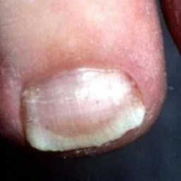  
 non-serious#1165  
**Analysis by this app:**normal = 1%; non-serious = 99%; check with a GP = 0%;   
The nail's condition is non-serious with confidence score of 99%.  
Otherwise it is normal with confidence score of 1%.×

 non-serious#945  
**Analysis by this app:**normal = 0%; non-serious = 99%; check with a GP = 1%;   
The nail's condition is non-serious with confidence score of 99%.  
The confidence score for consulting a GP is 1%.×

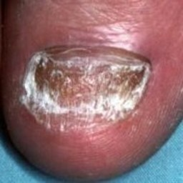  
 non-serious#1320  
**Analysis by this app:**normal = 0%; non-serious = 99%; check with a GP = 1%;   
The nail's condition is non-serious with confidence score of 99%.  
The confidence score for consulting a GP is 1%.×

 non-serious#550  
**Analysis by this app:**normal = 0%; non-serious = 99%; check with a GP = 1%;   
The nail's condition is non-serious with confidence score of 99%.  
The confidence score for consulting a GP is 1%.×

 non-serious#330  
**Analysis by this app:**normal = 0%; non-serious = 99%; check with a GP = 1%;   
The nail's condition is non-serious with confidence score of 99%.  
The confidence score for consulting a GP is 1%.×

 non-serious#755  
**Analysis by this app:**normal = 0%; non-serious = 99%; check with a GP = 1%;   
The nail's condition is non-serious with confidence score of 99%.  
The confidence score for consulting a GP is 1%.×

 non-serious#715  
**Analysis by this app:**normal = 0%; non-serious = 99%; check with a GP = 1%;   
The nail's condition is non-serious with confidence score of 99%.  
The confidence score for consulting a GP is 1%.×

 non-serious#415  
**Analysis by this app:**normal = 0%; non-serious = 99%; check with a GP = 1%;   
The nail's condition is non-serious with confidence score of 99%.  
The confidence score for consulting a GP is 1%.×

 non-serious#495  
**Analysis by this app:**normal = 0%; non-serious = 99%; check with a GP = 1%;   
The nail's condition is non-serious with confidence score of 99%.  
The confidence score for consulting a GP is 1%.×

 non-serious#520  
**Analysis by this app:**normal = 1%; non-serious = 99%; check with a GP = 0%;   
The nail's condition is non-serious with confidence score of 99%.  
Otherwise it is normal with confidence score of 1%.×

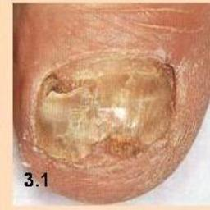  
 non-serious#1405  
**Analysis by this app:**normal = 0%; non-serious = 99%; check with a GP = 1%;   
The nail's condition is non-serious with confidence score of 99%.  
The confidence score for consulting a GP is 1%.×

 non-serious#805  
**Analysis by this app:**normal = 0%; non-serious = 99%; check with a GP = 1%;   
The nail's condition is non-serious with confidence score of 99%.  
The confidence score for consulting a GP is 1%.×

 non-serious#960  
**Analysis by this app:**normal = 0%; non-serious = 99%; check with a GP = 1%;   
The nail's condition is non-serious with confidence score of 99%.  
The confidence score for consulting a GP is 1%.×

 non-serious#425  
**Analysis by this app:**normal = 1%; non-serious = 99%; check with a GP = 0%;   
The nail's condition is non-serious with confidence score of 99%.  
Otherwise it is normal with confidence score of 1%.×

 non-serious#460  
**Analysis by this app:**normal = 0%; non-serious = 99%; check with a GP = 1%;   
The nail's condition is non-serious with confidence score of 99%.  
The confidence score for consulting a GP is 1%.×

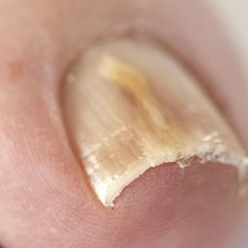  
 non-serious#1150  
**Analysis by this app:**normal = 0%; non-serious = 99%; check with a GP = 1%;   
The nail's condition is non-serious with confidence score of 99%.  
The confidence score for consulting a GP is 1%.×

 non-serious#540  
**Analysis by this app:**normal = 0%; non-serious = 99%; check with a GP = 1%;   
The nail's condition is non-serious with confidence score of 99%.  
The confidence score for consulting a GP is 1%.×

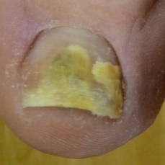  
 non-serious#1090  
**Analysis by this app:**normal = 0%; non-serious = 99%; check with a GP = 1%;   
The nail's condition is non-serious with confidence score of 99%.  
The confidence score for consulting a GP is 1%.×

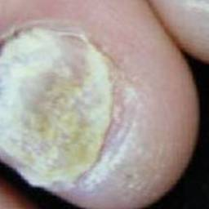  
 non-serious#1355  
**Analysis by this app:**normal = 1%; non-serious = 99%; check with a GP = 0%;   
The nail's condition is non-serious with confidence score of 99%.  
Otherwise it is normal with confidence score of 1%.×

 non-serious#510  
**Analysis by this app:**normal = 0%; non-serious = 99%; check with a GP = 1%;   
The nail's condition is non-serious with confidence score of 99%.  
The confidence score for consulting a GP is 1%.×

 non-serious#910  
**Analysis by this app:**normal = 0%; non-serious = 99%; check with a GP = 1%;   
The nail's condition is non-serious with confidence score of 99%.  
The confidence score for consulting a GP is 1%.×

 non-serious#20  
**Analysis by this app:**normal = 0%; non-serious = 99%; check with a GP = 1%;   
The nail's condition is non-serious with confidence score of 99%.  
The confidence score for consulting a GP is 1%.×

 non-serious#320  
**Analysis by this app:**normal = 0%; non-serious = 99%; check with a GP = 1%;   
The nail's condition is non-serious with confidence score of 99%.  
The confidence score for consulting a GP is 1%.×

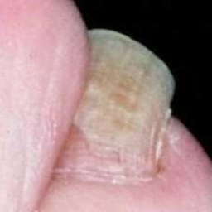  
 non-serious#1385  
**Analysis by this app:**normal = 1%; non-serious = 99%; check with a GP = 0%;   
The nail's condition is non-serious with confidence score of 99%.  
Otherwise it is normal with confidence score of 1%.×

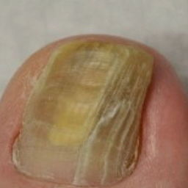  
 non-serious#1420  
**Analysis by this app:**normal = 0%; non-serious = 99%; check with a GP = 1%;   
The nail's condition is non-serious with confidence score of 99%.  
The confidence score for consulting a GP is 1%.×

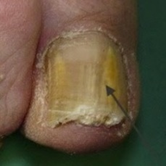  
 non-serious#1230  
**Analysis by this app:**normal = 1%; non-serious = 98%; check with a GP = 1%;   
The nail's condition is non-serious with confidence score of 98%.  
Otherwise it is normal with confidence score of 1%.×

 non-serious#55  
**Analysis by this app:**normal = 1%; non-serious = 98%; check with a GP = 0%;   
The nail's condition is non-serious with confidence score of 98%.  
Otherwise it is normal with confidence score of 1%.×

 non-serious#570  
**Analysis by this app:**normal = 0%; non-serious = 98%; check with a GP = 2%;   
The nail's condition is non-serious with confidence score of 98%.  
The confidence score for consulting a GP is 2%.×

 non-serious#15  
**Analysis by this app:**normal = 0%; non-serious = 98%; check with a GP = 2%;   
The nail's condition is non-serious with confidence score of 98%.  
The confidence score for consulting a GP is 2%.×

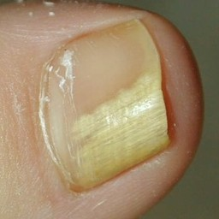  
 non-serious#1010  
**Analysis by this app:**normal = 1%; non-serious = 98%; check with a GP = 1%;   
The nail's condition is non-serious with confidence score of 98%.  
Otherwise it is normal with confidence score of 1%.×

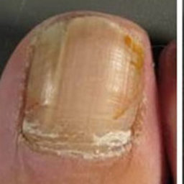  
 non-serious#1070  
**Analysis by this app:**normal = 0%; non-serious = 98%; check with a GP = 2%;   
The nail's condition is non-serious with confidence score of 98%.  
The confidence score for consulting a GP is 2%.×

 non-serious#560  
**Analysis by this app:**normal = 2%; non-serious = 98%; check with a GP = 0%;   
The nail's condition is non-serious with confidence score of 98%.  
Otherwise it is normal with confidence score of 2%.×

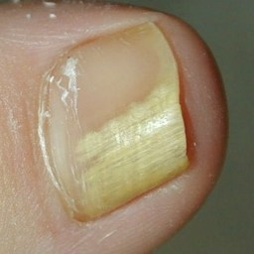  
 non-serious#1430  
**Analysis by this app:**normal = 0%; non-serious = 98%; check with a GP = 2%;   
The nail's condition is non-serious with confidence score of 98%.  
The confidence score for consulting a GP is 2%.×

 non-serious#530  
**Analysis by this app:**normal = 0%; non-serious = 98%; check with a GP = 2%;   
The nail's condition is non-serious with confidence score of 98%.  
The confidence score for consulting a GP is 2%.×

 non-serious#730  
**Analysis by this app:**normal = 1%; non-serious = 98%; check with a GP = 2%;   
The nail's condition is non-serious with confidence score of 98%.  
The confidence score for consulting a GP is 2%.×

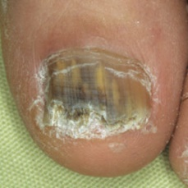  
 non-serious#1510  
**Analysis by this app:**normal = 0%; non-serious = 98%; check with a GP = 2%;   
The nail's condition is non-serious with confidence score of 98%.  
The confidence score for consulting a GP is 2%.×

 non-serious#525  
**Analysis by this app:**normal = 0%; non-serious = 97%; check with a GP = 2%;   
The nail's condition is non-serious with confidence score of 97%.  
The confidence score for consulting a GP is 2%.×

 non-serious#435  
**Analysis by this app:**normal = 1%; non-serious = 97%; check with a GP = 2%;   
The nail's condition is non-serious with confidence score of 97%.  
The confidence score for consulting a GP is 2%.×

 non-serious#475  
**Analysis by this app:**normal = 2%; non-serious = 97%; check with a GP = 1%;   
The nail's condition is non-serious with confidence score of 97%.  
Otherwise it is normal with confidence score of 2%.×

 non-serious#985  
**Analysis by this app:**normal = 0%; non-serious = 97%; check with a GP = 2%;   
The nail's condition is non-serious with confidence score of 97%.  
The confidence score for consulting a GP is 2%.×

 non-serious#615  
**Analysis by this app:**normal = 0%; non-serious = 97%; check with a GP = 3%;   
The nail's condition is non-serious with confidence score of 97%.  
The confidence score for consulting a GP is 3%.×

 non-serious#265  
**Analysis by this app:**normal = 1%; non-serious = 97%; check with a GP = 2%;   
The nail's condition is non-serious with confidence score of 97%.  
The confidence score for consulting a GP is 2%.×

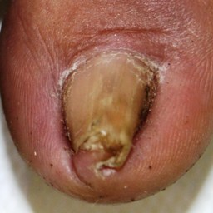  
 non-serious#1265  
**Analysis by this app:**normal = 0%; non-serious = 97%; check with a GP = 3%;   
The nail's condition is non-serious with confidence score of 97%.  
The confidence score for consulting a GP is 3%.×

 non-serious#995  
**Analysis by this app:**normal = 1%; non-serious = 97%; check with a GP = 2%;   
The nail's condition is non-serious with confidence score of 97%.  
The confidence score for consulting a GP is 2%.×

 non-serious#25  
**Analysis by this app:**normal = 0%; non-serious = 97%; check with a GP = 3%;   
The nail's condition is non-serious with confidence score of 97%.  
The confidence score for consulting a GP is 3%.×

 non-serious#545  
**Analysis by this app:**normal = 1%; non-serious = 97%; check with a GP = 3%;   
The nail's condition is non-serious with confidence score of 97%.  
The confidence score for consulting a GP is 3%.×

 non-serious#240  
**Analysis by this app:**normal = 3%; non-serious = 97%; check with a GP = 1%;   
The nail's condition is non-serious with confidence score of 97%.  
Otherwise it is normal with confidence score of 3%.×

 non-serious#380  
**Analysis by this app:**normal = 0%; non-serious = 97%; check with a GP = 3%;   
The nail's condition is non-serious with confidence score of 97%.  
The confidence score for consulting a GP is 3%.×

 non-serious#810  
**Analysis by this app:**normal = 3%; non-serious = 97%; check with a GP = 0%;   
The nail's condition is non-serious with confidence score of 97%.  
Otherwise it is normal with confidence score of 3%.×

 non-serious#735  
**Analysis by this app:**normal = 1%; non-serious = 97%; check with a GP = 3%;   
The nail's condition is non-serious with confidence score of 97%.  
The confidence score for consulting a GP is 3%.×

 non-serious#285  
**Analysis by this app:**normal = 0%; non-serious = 97%; check with a GP = 3%;   
The nail's condition is non-serious with confidence score of 97%.  
The confidence score for consulting a GP is 3%.×

 non-serious#695  
**Analysis by this app:**normal = 0%; non-serious = 97%; check with a GP = 3%;   
The nail's condition is non-serious with confidence score of 97%.  
The confidence score for consulting a GP is 3%.×

 non-serious#790  
**Analysis by this app:**normal = 2%; non-serious = 97%; check with a GP = 1%;   
The nail's condition is non-serious with confidence score of 97%.  
Otherwise it is normal with confidence score of 2%.×

 non-serious#890  
**Analysis by this app:**normal = 1%; non-serious = 97%; check with a GP = 3%;   
The nail's condition is non-serious with confidence score of 97%.  
The confidence score for consulting a GP is 3%.×

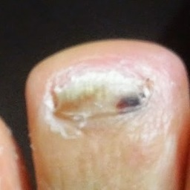  
 non-serious#1580  
**Analysis by this app:**normal = 3%; non-serious = 97%; check with a GP = 0%;   
The nail's condition is non-serious with confidence score of 97%.  
Otherwise it is normal with confidence score of 3%.×

 non-serious#30  
**Analysis by this app:**normal = 2%; non-serious = 97%; check with a GP = 2%;   
The nail's condition is non-serious with confidence score of 97%.  
Otherwise it is normal with confidence score of 2%.×

 non-serious#765  
**Analysis by this app:**normal = 0%; non-serious = 97%; check with a GP = 3%;   
The nail's condition is non-serious with confidence score of 97%.  
The confidence score for consulting a GP is 3%.×

 non-serious#820  
**Analysis by this app:**normal = 2%; non-serious = 96%; check with a GP = 2%;   
The nail's condition is non-serious with confidence score of 96%.  
Otherwise it is normal with confidence score of 2%.×

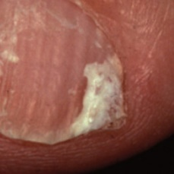  
 non-serious#1370  
**Analysis by this app:**normal = 3%; non-serious = 96%; check with a GP = 1%;   
The nail's condition is non-serious with confidence score of 96%.  
Otherwise it is normal with confidence score of 3%.×

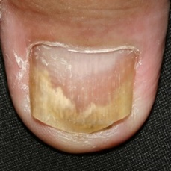  
 non-serious#1065  
**Analysis by this app:**normal = 0%; non-serious = 96%; check with a GP = 4%;   
The nail's condition is non-serious with confidence score of 96%.  
The confidence score for consulting a GP is 4%.×

 non-serious#770  
**Analysis by this app:**normal = 0%; non-serious = 96%; check with a GP = 4%;   
The nail's condition is non-serious with confidence score of 96%.  
The confidence score for consulting a GP is 4%.×

 non-serious#210  
**Analysis by this app:**normal = 4%; non-serious = 96%; check with a GP = 0%;   
The nail's condition is non-serious with confidence score of 96%.  
Otherwise it is normal with confidence score of 4%.×

 non-serious#815  
**Analysis by this app:**normal = 1%; non-serious = 96%; check with a GP = 3%;   
The nail's condition is non-serious with confidence score of 96%.  
The confidence score for consulting a GP is 3%.×

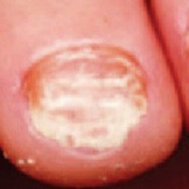  
 non-serious#1135  
**Analysis by this app:**normal = 1%; non-serious = 96%; check with a GP = 3%;   
The nail's condition is non-serious with confidence score of 96%.  
The confidence score for consulting a GP is 3%.×

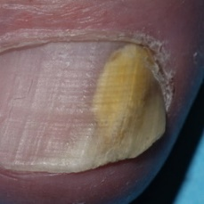  
 non-serious#1205  
**Analysis by this app:**normal = 2%; non-serious = 96%; check with a GP = 2%;   
The nail's condition is non-serious with confidence score of 96%.  
Otherwise it is normal with confidence score of 2%.×

 non-serious#335  
**Analysis by this app:**normal = 1%; non-serious = 96%; check with a GP = 3%;   
The nail's condition is non-serious with confidence score of 96%.  
The confidence score for consulting a GP is 3%.×

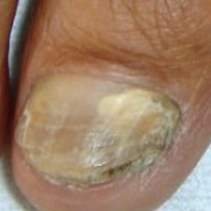  
 non-serious#1030  
**Analysis by this app:**normal = 1%; non-serious = 96%; check with a GP = 3%;   
The nail's condition is non-serious with confidence score of 96%.  
The confidence score for consulting a GP is 3%.×

 non-serious#925  
**Analysis by this app:**normal = 0%; non-serious = 96%; check with a GP = 4%;   
The nail's condition is non-serious with confidence score of 96%.  
The confidence score for consulting a GP is 4%.×

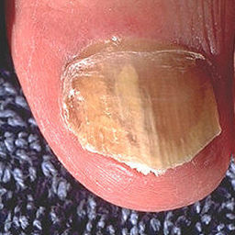  
 non-serious#1590  
**Analysis by this app:**normal = 0%; non-serious = 96%; check with a GP = 4%;   
The nail's condition is non-serious with confidence score of 96%.  
The confidence score for consulting a GP is 4%.×

  
 non-serious#1295  
**Analysis by this app:**normal = 0%; non-serious = 96%; check with a GP = 4%;   
The nail's condition is non-serious with confidence score of 96%.  
The confidence score for consulting a GP is 4%.×

  
 non-serious#1080  
**Analysis by this app:**normal = 0%; non-serious = 96%; check with a GP = 4%;   
The nail's condition is non-serious with confidence score of 96%.  
The confidence score for consulting a GP is 4%.×

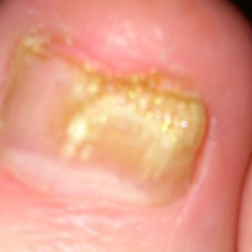  
 non-serious#1445  
**Analysis by this app:**normal = 4%; non-serious = 96%; check with a GP = 1%;   
The nail's condition is non-serious with confidence score of 96%.  
Otherwise it is normal with confidence score of 4%.×

 non-serious#0  
**Analysis by this app:**normal = 4%; non-serious = 96%; check with a GP = 0%;   
The nail's condition is non-serious with confidence score of 96%.  
Otherwise it is normal with confidence score of 4%.×

 non-serious#190  
**Analysis by this app:**normal = 0%; non-serious = 96%; check with a GP = 4%;   
The nail's condition is non-serious with confidence score of 96%.  
The confidence score for consulting a GP is 4%.×

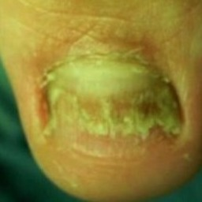  
 non-serious#1565  
**Analysis by this app:**normal = 1%; non-serious = 96%; check with a GP = 4%;   
The nail's condition is non-serious with confidence score of 96%.  
The confidence score for consulting a GP is 4%.×

 non-serious#500  
**Analysis by this app:**normal = 2%; non-serious = 95%; check with a GP = 3%;   
The nail's condition is non-serious with confidence score of 95%.  
The confidence score for consulting a GP is 3%.×

 non-serious#280  
**Analysis by this app:**normal = 4%; non-serious = 95%; check with a GP = 0%;   
The nail's condition is non-serious with confidence score of 95%.  
Otherwise it is normal with confidence score of 4%.×

 non-serious#225  
**Analysis by this app:**normal = 3%; non-serious = 95%; check with a GP = 1%;   
The nail's condition is non-serious with confidence score of 95%.  
Otherwise it is normal with confidence score of 3%.×

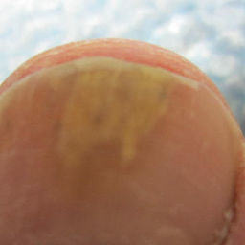  
 non-serious#1530  
**Analysis by this app:**normal = 2%; non-serious = 95%; check with a GP = 2%;   
The nail's condition is non-serious with confidence score of 95%.  
Otherwise it is normal with confidence score of 2%.×

 non-serious#905  
**Analysis by this app:**normal = 0%; non-serious = 95%; check with a GP = 4%;   
The nail's condition is non-serious with confidence score of 95%.  
The confidence score for consulting a GP is 4%.×

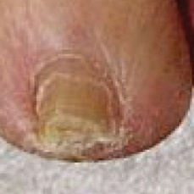  
 non-serious#1125  
**Analysis by this app:**normal = 0%; non-serious = 95%; check with a GP = 5%;   
The nail's condition is non-serious with confidence score of 95%.  
The confidence score for consulting a GP is 5%.×

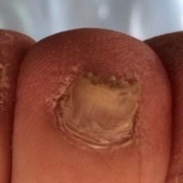  
 non-serious#1435  
**Analysis by this app:**normal = 0%; non-serious = 95%; check with a GP = 5%;   
The nail's condition is non-serious with confidence score of 95%.  
The confidence score for consulting a GP is 5%.×

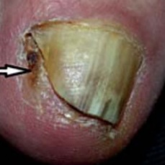  
 non-serious#1025  
**Analysis by this app:**normal = 2%; non-serious = 95%; check with a GP = 3%;   
The nail's condition is non-serious with confidence score of 95%.  
The confidence score for consulting a GP is 3%.×

 non-serious#150  
**Analysis by this app:**normal = 1%; non-serious = 95%; check with a GP = 5%;   
The nail's condition is non-serious with confidence score of 95%.  
The confidence score for consulting a GP is 5%.×

 non-serious#70  
**Analysis by this app:**normal = 1%; non-serious = 95%; check with a GP = 4%;   
The nail's condition is non-serious with confidence score of 95%.  
The confidence score for consulting a GP is 4%.×

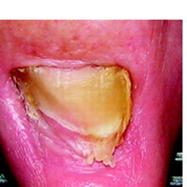  
 non-serious#1225  
**Analysis by this app:**normal = 0%; non-serious = 95%; check with a GP = 5%;   
The nail's condition is non-serious with confidence score of 95%.  
The confidence score for consulting a GP is 5%.×

 non-serious#455  
**Analysis by this app:**normal = 1%; non-serious = 94%; check with a GP = 5%;   
The nail's condition is non-serious with confidence score of 94%.  
The confidence score for consulting a GP is 5%.×

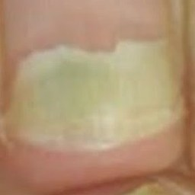  
 non-serious#1595  
**Analysis by this app:**normal = 2%; non-serious = 94%; check with a GP = 4%;   
The nail's condition is non-serious with confidence score of 94%.  
The confidence score for consulting a GP is 4%.×

 non-serious#85  
**Analysis by this app:**normal = 6%; non-serious = 94%; check with a GP = 0%;   
The nail's condition is non-serious with confidence score of 94%.  
Otherwise it is normal with confidence score of 6%.×

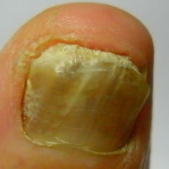  
 non-serious#1560  
**Analysis by this app:**normal = 0%; non-serious = 94%; check with a GP = 6%;   
The nail's condition is non-serious with confidence score of 94%.  
The confidence score for consulting a GP is 6%.×

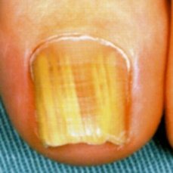  
 non-serious#1555  
**Analysis by this app:**normal = 0%; non-serious = 94%; check with a GP = 6%;   
The nail's condition is non-serious with confidence score of 94%.  
The confidence score for consulting a GP is 6%.×

 non-serious#875  
**Analysis by this app:**normal = 0%; non-serious = 94%; check with a GP = 6%;   
The nail's condition is non-serious with confidence score of 94%.  
The confidence score for consulting a GP is 6%.×

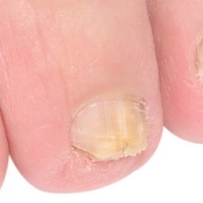  
 non-serious#1415  
**Analysis by this app:**normal = 5%; non-serious = 93%; check with a GP = 1%;   
The nail's condition is non-serious with confidence score of 93%.  
Otherwise it is normal with confidence score of 5%.×

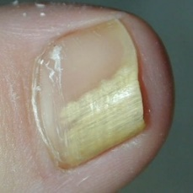  
 non-serious#1140  
**Analysis by this app:**normal = 3%; non-serious = 93%; check with a GP = 4%;   
The nail's condition is non-serious with confidence score of 93%.  
The confidence score for consulting a GP is 4%.×

 non-serious#430  
**Analysis by this app:**normal = 3%; non-serious = 93%; check with a GP = 4%;   
The nail's condition is non-serious with confidence score of 93%.  
The confidence score for consulting a GP is 4%.×

 non-serious#685  
**Analysis by this app:**normal = 0%; non-serious = 93%; check with a GP = 7%;   
The nail's condition is non-serious with confidence score of 93%.  
The confidence score for consulting a GP is 7%.×

 non-serious#600  
**Analysis by this app:**normal = 0%; non-serious = 93%; check with a GP = 7%;   
The nail's condition is non-serious with confidence score of 93%.  
The confidence score for consulting a GP is 7%.×

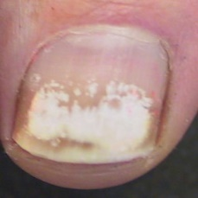  
 non-serious#1330  
**Analysis by this app:**normal = 7%; non-serious = 93%; check with a GP = 1%;   
The nail's condition is non-serious with confidence score of 93%.  
Otherwise it is normal with confidence score of 7%.×

 non-serious#5  
**Analysis by this app:**normal = 7%; non-serious = 93%; check with a GP = 0%;   
The nail's condition is non-serious with confidence score of 93%.  
Otherwise it is normal with confidence score of 7%.×

 non-serious#785  
**Analysis by this app:**normal = 3%; non-serious = 92%; check with a GP = 4%;   
The nail's condition is non-serious with confidence score of 92%.  
The confidence score for consulting a GP is 4%.×

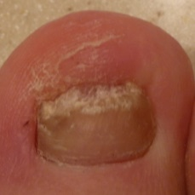  
 non-serious#1410  
**Analysis by this app:**normal = 3%; non-serious = 92%; check with a GP = 5%;   
The nail's condition is non-serious with confidence score of 92%.  
The confidence score for consulting a GP is 5%.×

 non-serious#610  
**Analysis by this app:**normal = 3%; non-serious = 92%; check with a GP = 5%;   
The nail's condition is non-serious with confidence score of 92%.  
The confidence score for consulting a GP is 5%.×

 non-serious#585  
**Analysis by this app:**normal = 0%; non-serious = 92%; check with a GP = 8%;   
The nail's condition is non-serious with confidence score of 92%.  
The confidence score for consulting a GP is 8%.×

 non-serious#180  
**Analysis by this app:**normal = 2%; non-serious = 92%; check with a GP = 6%;   
The nail's condition is non-serious with confidence score of 92%.  
The confidence score for consulting a GP is 6%.×

 non-serious#635  
**Analysis by this app:**normal = 6%; non-serious = 91%; check with a GP = 2%;   
The nail's condition is non-serious with confidence score of 91%.  
Otherwise it is normal with confidence score of 6%.×

 non-serious#565  
**Analysis by this app:**normal = 6%; non-serious = 91%; check with a GP = 2%;   
The nail's condition is non-serious with confidence score of 91%.  
Otherwise it is normal with confidence score of 6%.×

 non-serious#295  
**Analysis by this app:**normal = 6%; non-serious = 91%; check with a GP = 3%;   
The nail's condition is non-serious with confidence score of 91%.  
Otherwise it is normal with confidence score of 6%.×

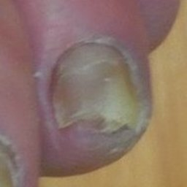  
 non-serious#1110  
**Analysis by this app:**normal = 2%; non-serious = 91%; check with a GP = 7%;   
The nail's condition is non-serious with confidence score of 91%.  
The confidence score for consulting a GP is 7%.×

 non-serious#650  
**Analysis by this app:**normal = 1%; non-serious = 91%; check with a GP = 8%;   
The nail's condition is non-serious with confidence score of 91%.  
The confidence score for consulting a GP is 8%.×

 non-serious#215  
**Analysis by this app:**normal = 7%; non-serious = 91%; check with a GP = 2%;   
The nail's condition is non-serious with confidence score of 91%.  
Otherwise it is normal with confidence score of 7%.×

 non-serious#450  
**Analysis by this app:**normal = 2%; non-serious = 90%; check with a GP = 8%;   
The nail's condition is non-serious with confidence score of 90%.  
The confidence score for consulting a GP is 8%.×

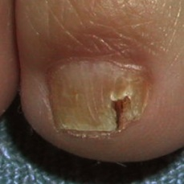  
 non-serious#1085  
**Analysis by this app:**normal = 9%; non-serious = 90%; check with a GP = 1%;   
The nail's condition is non-serious with confidence score of 90%.  
Otherwise it is normal with confidence score of 9%.×

 non-serious#110  
**Analysis by this app:**normal = 8%; non-serious = 90%; check with a GP = 3%;   
The nail's condition is non-serious with confidence score of 90%.  
Otherwise it is normal with confidence score of 8%.×

 non-serious#290  
**Analysis by this app:**normal = 1%; non-serious = 89%; check with a GP = 9%;   
The nail's condition is non-serious with confidence score of 89%.  
The confidence score for consulting a GP is 9%.×

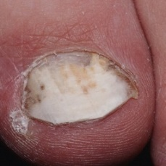  
 non-serious#1185  
**Analysis by this app:**normal = 1%; non-serious = 89%; check with a GP = 9%;   
The nail's condition is non-serious with confidence score of 89%.  
The confidence score for consulting a GP is 9%.×

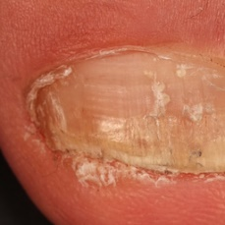  
 non-serious#1340  
**Analysis by this app:**normal = 8%; non-serious = 89%; check with a GP = 4%;   
The nail's condition is non-serious with confidence score of 89%.  
Otherwise it is normal with confidence score of 8%.×

 non-serious#515  
**Analysis by this app:**normal = 0%; non-serious = 88%; check with a GP = 12%;   
The nail's condition is non-serious with confidence score of 88%.  
The confidence score for consulting a GP is 12%.×

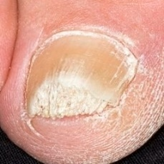  
 non-serious#1095  
**Analysis by this app:**normal = 12%; non-serious = 88%; check with a GP = 1%;   
The nail's condition is non-serious with confidence score of 88%.  
Otherwise it is normal with confidence score of 12%.×

 non-serious#710  
**Analysis by this app:**normal = 7%; non-serious = 88%; check with a GP = 5%;   
The nail's condition is non-serious with confidence score of 88%.  
Otherwise it is normal with confidence score of 7%.×

 non-serious#365  
**Analysis by this app:**normal = 4%; non-serious = 86%; check with a GP = 10%;   
The nail's condition is non-serious with confidence score of 86%.  
The confidence score for consulting a GP is 10%.×

 non-serious#275  
**Analysis by this app:**normal = 1%; non-serious = 86%; check with a GP = 13%;   
The nail's condition is non-serious with confidence score of 86%.  
The confidence score for consulting a GP is 13%.×

 non-serious#350  
**Analysis by this app:**normal = 6%; non-serious = 86%; check with a GP = 8%;   
The nail's condition is non-serious with confidence score of 86%.  
The confidence score for consulting a GP is 8%.×

 non-serious#165  
**Analysis by this app:**normal = 1%; non-serious = 86%; check with a GP = 13%;   
The nail's condition is non-serious with confidence score of 86%.  
The confidence score for consulting a GP is 13%.×

 non-serious#385  
**Analysis by this app:**normal = 2%; non-serious = 86%; check with a GP = 12%;   
The nail's condition is non-serious with confidence score of 86%.  
The confidence score for consulting a GP is 12%.×

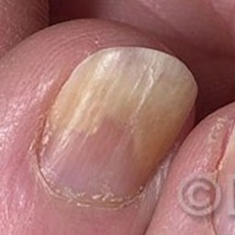  
 non-serious#1290  
**Analysis by this app:**normal = 12%; non-serious = 85%; check with a GP = 3%;   
The nail's condition is non-serious with confidence score of 85%.  
Otherwise it is normal with confidence score of 12%.×

 non-serious#170  
**Analysis by this app:**normal = 1%; non-serious = 85%; check with a GP = 14%;   
The nail's condition is non-serious with confidence score of 85%.  
The confidence score for consulting a GP is 14%.×

 non-serious#825  
**Analysis by this app:**normal = 0%; non-serious = 85%; check with a GP = 15%;   
The nail's condition is non-serious with confidence score of 85%.  
The confidence score for consulting a GP is 15%.×

 non-serious#360  
**Analysis by this app:**normal = 2%; non-serious = 84%; check with a GP = 14%;   
The nail's condition is non-serious with confidence score of 84%.  
The confidence score for consulting a GP is 14%.×

 non-serious#445  
**Analysis by this app:**normal = 0%; non-serious = 84%; check with a GP = 16%;   
The nail's condition is non-serious with confidence score of 84%.  
The confidence score for consulting a GP is 16%.×

 non-serious#40  
**Analysis by this app:**normal = 10%; non-serious = 84%; check with a GP = 6%;   
The nail's condition is non-serious with confidence score of 84%.  
Otherwise it is normal with confidence score of 10%.×

 non-serious#175  
**Analysis by this app:**normal = 0%; non-serious = 84%; check with a GP = 16%;   
The nail's condition is non-serious with confidence score of 84%.  
The confidence score for consulting a GP is 16%.×

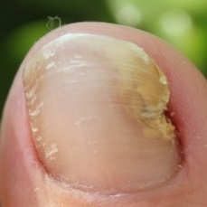  
 non-serious#1490  
**Analysis by this app:**normal = 16%; non-serious = 82%; check with a GP = 2%;   
The nail's condition is non-serious with confidence score of 82%.  
Otherwise it is normal with confidence score of 16%.×

 non-serious#35  
**Analysis by this app:**normal = 6%; non-serious = 81%; check with a GP = 13%;   
The nail's condition is non-serious with confidence score of 81%.  
The confidence score for consulting a GP is 13%.×

 non-serious#915  
**Analysis by this app:**normal = 6%; non-serious = 81%; check with a GP = 13%;   
The nail's condition is non-serious with confidence score of 81%.  
The confidence score for consulting a GP is 13%.×

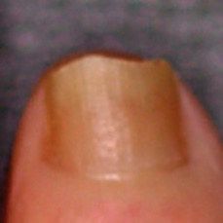  
 non-serious#1170  
**Analysis by this app:**normal = 1%; non-serious = 80%; check with a GP = 18%;   
The nail's condition is non-serious with confidence score of 80%.  
The confidence score for consulting a GP is 18%.×

 non-serious#410  
**Analysis by this app:**normal = 1%; non-serious = 80%; check with a GP = 19%;   
The nail's condition is non-serious with confidence score of 80%.  
The confidence score for consulting a GP is 19%.×

 non-serious#325  
**Analysis by this app:**normal = 5%; non-serious = 78%; check with a GP = 17%;   
The nail's condition is non-serious with confidence score of 78%.  
The confidence score for consulting a GP is 17%.×

 non-serious#400  
**Analysis by this app:**normal = 1%; non-serious = 78%; check with a GP = 21%;   
Perhaps a GP should be consulted (confidence score is 21%) ×

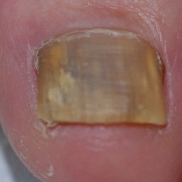  
 non-serious#1455  
**Analysis by this app:**normal = 0%; non-serious = 78%; check with a GP = 22%;   
Perhaps a GP should be consulted (confidence score is 22%) ×

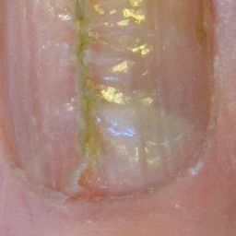  
 non-serious#1460  
**Analysis by this app:**normal = 3%; non-serious = 77%; check with a GP = 20%;   
Perhaps a GP should be consulted (confidence score is 20%) ×

 non-serious#260  
**Analysis by this app:**normal = 0%; non-serious = 76%; check with a GP = 24%;   
Perhaps a GP should be consulted (confidence score is 24%) ×

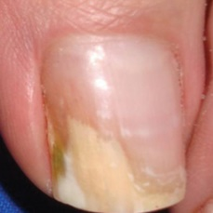  
 non-serious#1400  
**Analysis by this app:**normal = 7%; non-serious = 74%; check with a GP = 20%;   
Perhaps a GP should be consulted (confidence score is 20%) ×

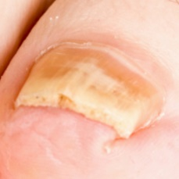  
 non-serious#1305  
**Analysis by this app:**normal = 29%; non-serious = 71%; check with a GP = 1%;   
The nail's condition is non-serious with confidence score of 71%.  
Otherwise it is normal with confidence score of 29%.×

 non-serious#345  
**Analysis by this app:**normal = 0%; non-serious = 70%; check with a GP = 30%;   
Perhaps a GP should be consulted (confidence score is 30%) ×

 non-serious#370  
**Analysis by this app:**normal = 1%; non-serious = 68%; check with a GP = 30%;   
Perhaps a GP should be consulted (confidence score is 30%) ×

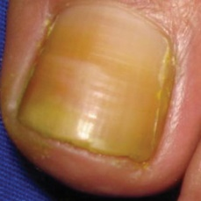  
 non-serious#1390  
**Analysis by this app:**normal = 26%; non-serious = 68%; check with a GP = 6%;   
The nail's condition is non-serious with confidence score of 68%.  
Otherwise it is normal with confidence score of 26%.×

http://localhost:8080/ai/onyx/images/fungal-nails/Slide22-2d.png  
 non-serious#1635  
**Analysis by this app:**normal = 31%; non-serious = 68%; check with a GP = 1%;   
The nail's condition is non-serious with confidence score of 68%.  
Otherwise it is normal with confidence score of 31%.×

 non-serious#700  
**Analysis by this app:**normal = 0%; non-serious = 67%; check with a GP = 32%;   
Perhaps a GP should be consulted (confidence score is 32%) ×

 non-serious#195  
**Analysis by this app:**normal = 13%; non-serious = 66%; check with a GP = 21%;   
Perhaps a GP should be consulted (confidence score is 21%) ×

 non-serious#605  
**Analysis by this app:**normal = 2%; non-serious = 65%; check with a GP = 33%;   
Perhaps a GP should be consulted (confidence score is 33%) ×

 non-serious#795  
**Analysis by this app:**normal = 2%; non-serious = 64%; check with a GP = 33%;   
Perhaps a GP should be consulted (confidence score is 33%) ×

 non-serious#375  
**Analysis by this app:**normal = 3%; non-serious = 64%; check with a GP = 34%;   
Perhaps a GP should be consulted (confidence score is 34%) ×

 non-serious#725  
**Analysis by this app:**normal = 1%; non-serious = 63%; check with a GP = 36%;   
Perhaps a GP should be consulted (confidence score is 36%) ×

 non-serious#505  
**Analysis by this app:**normal = 1%; non-serious = 60%; check with a GP = 38%;   
Perhaps a GP should be consulted (confidence score is 38%) ×

 non-serious#250  
**Analysis by this app:**normal = 11%; non-serious = 60%; check with a GP = 29%;   
Perhaps a GP should be consulted (confidence score is 29%) ×

 non-serious#105  
**Analysis by this app:**normal = 7%; non-serious = 59%; check with a GP = 34%;   
Not very sure whether the nail is OK or not. Sorry.×

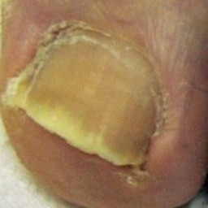  
 non-serious#1315  
**Analysis by this app:**normal = 40%; non-serious = 58%; check with a GP = 2%;   
Not very sure whether the nail is OK or not. Sorry.×

 non-serious#980  
**Analysis by this app:**normal = 2%; non-serious = 58%; check with a GP = 40%;   
Not very sure whether the nail is OK or not. Sorry.×

 non-serious#920  
**Analysis by this app:**normal = 36%; non-serious = 57%; check with a GP = 7%;   
Not very sure whether the nail is OK or not. Sorry.×

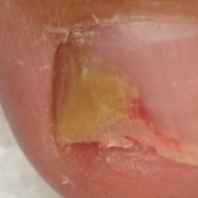  
 non-serious#1105  
**Analysis by this app:**normal = 7%; non-serious = 56%; check with a GP = 38%;   
Not very sure whether the nail is OK or not. Sorry.×

 non-serious#555  
**Analysis by this app:**normal = 6%; non-serious = 55%; check with a GP = 40%;   
Not very sure whether the nail is OK or not. Sorry.×

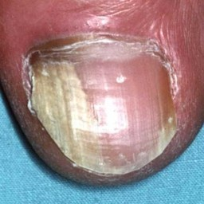  
 non-serious#1130  
**Analysis by this app:**normal = 1%; non-serious = 54%; check with a GP = 44%;   
Not very sure whether the nail is OK or not. Sorry.×

 non-serious#955  
**Analysis by this app:**normal = 12%; non-serious = 54%; check with a GP = 34%;   
Not very sure whether the nail is OK or not. Sorry.×

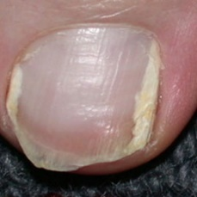  
 non-serious#1005  
**Analysis by this app:**normal = 46%; non-serious = 53%; check with a GP = 0%;   
Not very sure whether the nail is OK or not. Sorry.×

 non-serious#340  
**Analysis by this app:**normal = 47%; non-serious = 53%; check with a GP = 0%;   
Not very sure whether the nail is OK or not. Sorry.×

 non-serious#625  
**Analysis by this app:**normal = 0%; non-serious = 52%; check with a GP = 48%;   
Not very sure whether the nail is OK or not. Sorry.×

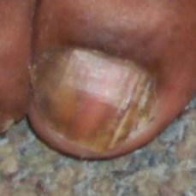  
 non-serious#1195  
**Analysis by this app:**normal = 41%; non-serious = 52%; check with a GP = 7%;   
Not very sure whether the nail is OK or not. Sorry.×

 non-serious#315  
**Analysis by this app:**normal = 49%; non-serious = 49%; check with a GP = 1%;   
Not very sure whether the nail is OK or not. Sorry.×

 non-serious#900  
**Analysis by this app:**normal = 13%; non-serious = 49%; check with a GP = 38%;   
Not very sure whether the nail is OK or not. Sorry.×

 non-serious#535  
**Analysis by this app:**normal = 0%; non-serious = 49%; check with a GP = 51%;   
Not very sure whether the nail is OK or not. Sorry.×

 non-serious#440  
**Analysis by this app:**normal = 51%; non-serious = 45%; check with a GP = 4%;   
Not very sure whether the nail is OK or not. Sorry.×

 non-serious#60  
**Analysis by this app:**normal = 0%; non-serious = 44%; check with a GP = 56%;   
Not very sure whether the nail is OK or not. Sorry.×

http://localhost:8080/ai/onyx/images/fungal-nails/Slide22-1c.png  
 non-serious#1630  
**Analysis by this app:**normal = 4%; non-serious = 43%; check with a GP = 53%;   
Not very sure whether the nail is OK or not. Sorry.×

 non-serious#305  
**Analysis by this app:**normal = 18%; non-serious = 40%; check with a GP = 41%;   
Not very sure whether the nail is OK or not. Sorry.×

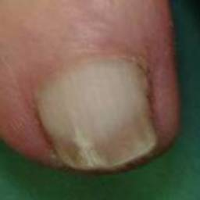  
 non-serious#1475  
**Analysis by this app:**normal = 50%; non-serious = 39%; check with a GP = 11%;   
Not very sure whether the nail is OK or not. Sorry.×

 non-serious#230  
**Analysis by this app:**normal = 60%; non-serious = 38%; check with a GP = 2%;   
The nail's condition is normal with confidence score of 60%.  
Otherwise it is non-serious with confidence score of 38%.×

 non-serious#835  
**Analysis by this app:**normal = 7%; non-serious = 36%; check with a GP = 57%;   
Not very sure whether the nail is OK or not. Sorry.×

 non-serious#775  
**Analysis by this app:**normal = 29%; non-serious = 34%; check with a GP = 37%;   
Not very sure whether the nail is OK or not. Sorry.×

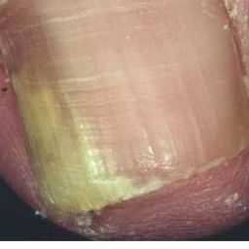  
 non-serious#1035  
**Analysis by this app:**normal = 16%; non-serious = 31%; check with a GP = 53%;   
Not very sure whether the nail is OK or not. Sorry.×

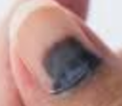  
 non-serious#1655  
**Analysis by this app:**normal = 58%; non-serious = 31%; check with a GP = 12%;   
Not very sure whether the nail is OK or not. Sorry.×

 non-serious#620  
**Analysis by this app:**normal = 3%; non-serious = 22%; check with a GP = 75%;   
It is most likely that the nail indicates something that warrants a second opinion and you should seek medical advice. (Confidence score is 75%)×

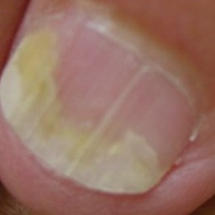  
 non-serious#1300  
**Analysis by this app:**normal = 80%; non-serious = 20%; check with a GP = 0%;   
The nail's condition is normal with confidence score of 80%.  
Otherwise it is non-serious with confidence score of 20%.×

  
 non-serious#1045  
**Analysis by this app:**normal = 80%; non-serious = 20%; check with a GP = 0%;   
The nail's condition is normal with confidence score of 80%.  
Otherwise it is non-serious with confidence score of 20%.×

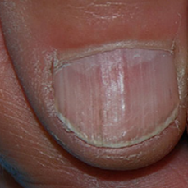  
 non-serious#1640  
**Analysis by this app:**normal = 62%; non-serious = 17%; check with a GP = 22%;   
Perhaps a GP should be consulted (confidence score is 22%) ×

 non-serious#420  
**Analysis by this app:**normal = 10%; non-serious = 10%; check with a GP = 80%;   
It is most likely that the nail indicates something that warrants a second opinion and you should seek medical advice. (Confidence score is 80%)×

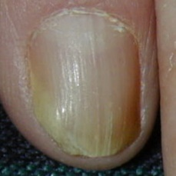  
 non-serious#1020  
**Analysis by this app:**normal = 8%; non-serious = 10%; check with a GP = 83%;   
It is most likely that the nail indicates something that warrants a second opinion and you should seek medical advice. (Confidence score is 83%)×

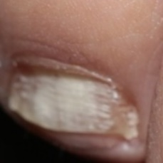  
 non-serious#1145  
**Analysis by this app:**normal = 96%; non-serious = 3%; check with a GP = 0%;   
The nail's condition is normal with confidence score of 96%.  
Otherwise it is non-serious with confidence score of 3%.×

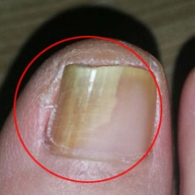  
 non-serious#1570  
**Analysis by this app:**normal = 25%; non-serious = 2%; check with a GP = 73%;   
It is most likely that the nail indicates something that warrants a second opinion and you should seek medical advice. (Confidence score is 73%)×

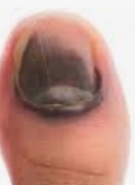  
 non-serious#1650  
**Analysis by this app:**normal = 1%; non-serious = 2%; check with a GP = 98%;   
It is most likely that the nail indicates something that warrants a second opinion and you should seek medical advice. (Confidence score is 98%)×

 non-serious#255  
**Analysis by this app:**normal = 1%; non-serious = 1%; check with a GP = 98%;   
It is most likely that the nail indicates something that warrants a second opinion and you should seek medical advice. (Confidence score is 98%)×

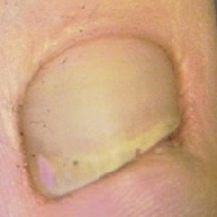  
 non-serious#1310  
**Analysis by this app:**normal = 92%; non-serious = 1%; check with a GP = 7%;   
The nail's condition is normal with confidence score of 92%.  
The confidence score for consulting a GP is 7%.×

 normal#726  
**Analysis by this app:**normal = 100%; non-serious = 0%; check with a GP = 0%;   
The nail's condition is normal with confidence score of 100%.×

 normal#511  
**Analysis by this app:**normal = 100%; non-serious = 0%; check with a GP = 0%;   
The nail's condition is normal with confidence score of 100%.×

 normal#76  
**Analysis by this app:**normal = 100%; non-serious = 0%; check with a GP = 0%;   
The nail's condition is normal with confidence score of 100%.×

 normal#1  
**Analysis by this app:**normal = 100%; non-serious = 0%; check with a GP = 0%;   
The nail's condition is normal with confidence score of 100%.×

 normal#171  
**Analysis by this app:**normal = 100%; non-serious = 0%; check with a GP = 0%;   
The nail's condition is normal with confidence score of 100%.×

 normal#576  
**Analysis by this app:**normal = 100%; non-serious = 0%; check with a GP = 0%;   
The nail's condition is normal with confidence score of 100%.×

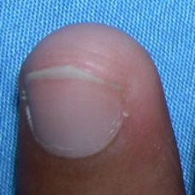  
 normal#1021  
**Analysis by this app:**normal = 100%; non-serious = 0%; check with a GP = 0%;   
The nail's condition is normal with confidence score of 100%.×

 normal#521  
**Analysis by this app:**normal = 100%; non-serious = 0%; check with a GP = 0%;   
The nail's condition is normal with confidence score of 100%.×

 normal#396  
**Analysis by this app:**normal = 100%; non-serious = 0%; check with a GP = 0%;   
The nail's condition is normal with confidence score of 100%.×

 normal#756  
**Analysis by this app:**normal = 100%; non-serious = 0%; check with a GP = 0%;   
The nail's condition is normal with confidence score of 100%.×

 normal#571  
**Analysis by this app:**normal = 100%; non-serious = 0%; check with a GP = 0%;   
The nail's condition is normal with confidence score of 100%.×

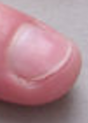  
 normal#1401  
**Analysis by this app:**normal = 100%; non-serious = 0%; check with a GP = 0%;   
The nail's condition is normal with confidence score of 100%.×

 normal#751  
**Analysis by this app:**normal = 100%; non-serious = 0%; check with a GP = 0%;   
The nail's condition is normal with confidence score of 100%.×

 normal#741  
**Analysis by this app:**normal = 100%; non-serious = 0%; check with a GP = 0%;   
The nail's condition is normal with confidence score of 100%.×

 normal#241  
**Analysis by this app:**normal = 100%; non-serious = 0%; check with a GP = 0%;   
The nail's condition is normal with confidence score of 100%.×

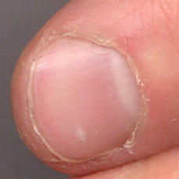  
 normal#1266  
**Analysis by this app:**normal = 100%; non-serious = 0%; check with a GP = 0%;   
The nail's condition is normal with confidence score of 100%.×

 normal#651  
**Analysis by this app:**normal = 100%; non-serious = 0%; check with a GP = 0%;   
The nail's condition is normal with confidence score of 100%.×

 normal#426  
**Analysis by this app:**normal = 100%; non-serious = 0%; check with a GP = 0%;   
The nail's condition is normal with confidence score of 100%.×

 normal#956  
**Analysis by this app:**normal = 100%; non-serious = 0%; check with a GP = 0%;   
The nail's condition is normal with confidence score of 100%.×

 normal#116  
**Analysis by this app:**normal = 100%; non-serious = 0%; check with a GP = 0%;   
The nail's condition is normal with confidence score of 100%.×

 normal#26  
**Analysis by this app:**normal = 100%; non-serious = 0%; check with a GP = 0%;   
The nail's condition is normal with confidence score of 100%.×

 normal#806  
**Analysis by this app:**normal = 100%; non-serious = 0%; check with a GP = 0%;   
The nail's condition is normal with confidence score of 100%.×

 normal#716  
**Analysis by this app:**normal = 100%; non-serious = 0%; check with a GP = 0%;   
The nail's condition is normal with confidence score of 100%.×

 normal#791  
**Analysis by this app:**normal = 100%; non-serious = 0%; check with a GP = 0%;   
The nail's condition is normal with confidence score of 100%.×

 normal#531  
**Analysis by this app:**normal = 100%; non-serious = 0%; check with a GP = 0%;   
The nail's condition is normal with confidence score of 100%.×

 normal#356  
**Analysis by this app:**normal = 100%; non-serious = 0%; check with a GP = 0%;   
The nail's condition is normal with confidence score of 100%.×

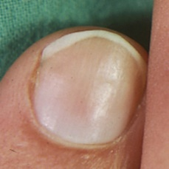  
 normal#1196  
**Analysis by this app:**normal = 100%; non-serious = 0%; check with a GP = 0%;   
The nail's condition is normal with confidence score of 100%.×

 normal#131  
**Analysis by this app:**normal = 100%; non-serious = 0%; check with a GP = 0%;   
The nail's condition is normal with confidence score of 100%.×

 normal#916  
**Analysis by this app:**normal = 100%; non-serious = 0%; check with a GP = 0%;   
The nail's condition is normal with confidence score of 100%.×

 normal#61  
**Analysis by this app:**normal = 100%; non-serious = 0%; check with a GP = 0%;   
The nail's condition is normal with confidence score of 100%.×

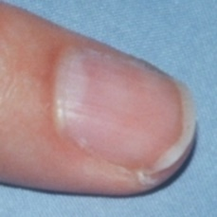  
 normal#1181  
**Analysis by this app:**normal = 100%; non-serious = 0%; check with a GP = 0%;   
The nail's condition is normal with confidence score of 100%.×

 normal#811  
**Analysis by this app:**normal = 100%; non-serious = 0%; check with a GP = 0%;   
The nail's condition is normal with confidence score of 100%.×

 normal#301  
**Analysis by this app:**normal = 99%; non-serious = 0%; check with a GP = 0%;   
The nail's condition is normal with confidence score of 99%.×

 normal#976  
**Analysis by this app:**normal = 99%; non-serious = 0%; check with a GP = 0%;   
The nail's condition is normal with confidence score of 99%.×

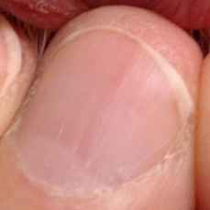  
 normal#1131  
**Analysis by this app:**normal = 99%; non-serious = 0%; check with a GP = 0%;   
The nail's condition is normal with confidence score of 99%.×

http://localhost:8080/ai/onyx/images/normal/Fingernail%20healthy%20Image_8b.png  
 normal#1431  
**Analysis by this app:**normal = 99%; non-serious = 0%; check with a GP = 0%;   
The nail's condition is normal with confidence score of 99%.×

http://localhost:8080/ai/onyx/images/normal/Fingernail%20healthy%20Image_18c.png  
 normal#1396  
**Analysis by this app:**normal = 99%; non-serious = 0%; check with a GP = 1%;   
The nail's condition is normal with confidence score of 99%.  
The confidence score for consulting a GP is 1%.×

 normal#996  
**Analysis by this app:**normal = 99%; non-serious = 0%; check with a GP = 1%;   
The nail's condition is normal with confidence score of 99%.  
The confidence score for consulting a GP is 1%.×

 normal#481  
**Analysis by this app:**normal = 99%; non-serious = 0%; check with a GP = 1%;   
The nail's condition is normal with confidence score of 99%.  
The confidence score for consulting a GP is 1%.×

 normal#986  
**Analysis by this app:**normal = 99%; non-serious = 0%; check with a GP = 1%;   
The nail's condition is normal with confidence score of 99%.  
The confidence score for consulting a GP is 1%.×

 normal#401  
**Analysis by this app:**normal = 99%; non-serious = 0%; check with a GP = 1%;   
The nail's condition is normal with confidence score of 99%.  
The confidence score for consulting a GP is 1%.×

 normal#16  
**Analysis by this app:**normal = 99%; non-serious = 0%; check with a GP = 1%;   
The nail's condition is normal with confidence score of 99%.  
The confidence score for consulting a GP is 1%.×

 normal#451  
**Analysis by this app:**normal = 99%; non-serious = 0%; check with a GP = 1%;   
The nail's condition is normal with confidence score of 99%.  
The confidence score for consulting a GP is 1%.×

 normal#486  
**Analysis by this app:**normal = 99%; non-serious = 1%; check with a GP = 0%;   
The nail's condition is normal with confidence score of 99%.  
Otherwise it is non-serious with confidence score of 1%.×

 normal#626  
**Analysis by this app:**normal = 99%; non-serious = 0%; check with a GP = 1%;   
The nail's condition is normal with confidence score of 99%.  
The confidence score for consulting a GP is 1%.×

 normal#951  
**Analysis by this app:**normal = 99%; non-serious = 0%; check with a GP = 1%;   
The nail's condition is normal with confidence score of 99%.  
The confidence score for consulting a GP is 1%.×

 normal#526  
**Analysis by this app:**normal = 99%; non-serious = 0%; check with a GP = 1%;   
The nail's condition is normal with confidence score of 99%.  
The confidence score for consulting a GP is 1%.×

 normal#761  
**Analysis by this app:**normal = 99%; non-serious = 1%; check with a GP = 0%;   
The nail's condition is normal with confidence score of 99%.  
Otherwise it is non-serious with confidence score of 1%.×

 normal#836  
**Analysis by this app:**normal = 99%; non-serious = 1%; check with a GP = 0%;   
The nail's condition is normal with confidence score of 99%.  
Otherwise it is non-serious with confidence score of 1%.×

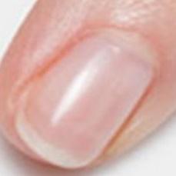  
 normal#1381  
**Analysis by this app:**normal = 99%; non-serious = 0%; check with a GP = 1%;   
The nail's condition is normal with confidence score of 99%.  
The confidence score for consulting a GP is 1%.×

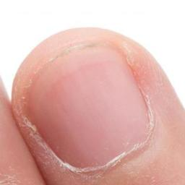  
 normal#1136  
**Analysis by this app:**normal = 99%; non-serious = 0%; check with a GP = 1%;   
The nail's condition is normal with confidence score of 99%.  
The confidence score for consulting a GP is 1%.×

 normal#551  
**Analysis by this app:**normal = 99%; non-serious = 0%; check with a GP = 1%;   
The nail's condition is normal with confidence score of 99%.  
The confidence score for consulting a GP is 1%.×

 normal#391  
**Analysis by this app:**normal = 99%; non-serious = 0%; check with a GP = 1%;   
The nail's condition is normal with confidence score of 99%.  
The confidence score for consulting a GP is 1%.×

 normal#776  
**Analysis by this app:**normal = 99%; non-serious = 0%; check with a GP = 1%;   
The nail's condition is normal with confidence score of 99%.  
The confidence score for consulting a GP is 1%.×

 normal#981  
**Analysis by this app:**normal = 99%; non-serious = 0%; check with a GP = 1%;   
The nail's condition is normal with confidence score of 99%.  
The confidence score for consulting a GP is 1%.×

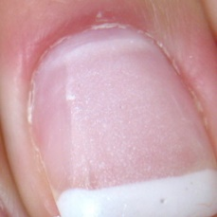  
 normal#1351  
**Analysis by this app:**normal = 99%; non-serious = 0%; check with a GP = 1%;   
The nail's condition is normal with confidence score of 99%.  
The confidence score for consulting a GP is 1%.×

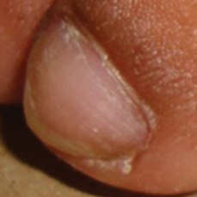  
 normal#1126  
**Analysis by this app:**normal = 99%; non-serious = 1%; check with a GP = 0%;   
The nail's condition is normal with confidence score of 99%.  
Otherwise it is non-serious with confidence score of 1%.×

 normal#1001  
**Analysis by this app:**normal = 99%; non-serious = 0%; check with a GP = 1%;   
The nail's condition is normal with confidence score of 99%.  
The confidence score for consulting a GP is 1%.×

 normal#256  
**Analysis by this app:**normal = 99%; non-serious = 0%; check with a GP = 1%;   
The nail's condition is normal with confidence score of 99%.  
The confidence score for consulting a GP is 1%.×

 normal#336  
**Analysis by this app:**normal = 99%; non-serious = 0%; check with a GP = 1%;   
The nail's condition is normal with confidence score of 99%.  
The confidence score for consulting a GP is 1%.×

 normal#731  
**Analysis by this app:**normal = 99%; non-serious = 1%; check with a GP = 0%;   
The nail's condition is normal with confidence score of 99%.  
Otherwise it is non-serious with confidence score of 1%.×

 normal#6  
**Analysis by this app:**normal = 99%; non-serious = 0%; check with a GP = 1%;   
The nail's condition is normal with confidence score of 99%.  
The confidence score for consulting a GP is 1%.×

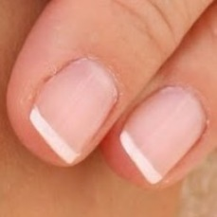  
 normal#1171  
**Analysis by this app:**normal = 98%; non-serious = 1%; check with a GP = 0%;   
The nail's condition is normal with confidence score of 98%.  
Otherwise it is non-serious with confidence score of 1%.×

 normal#111  
**Analysis by this app:**normal = 98%; non-serious = 0%; check with a GP = 2%;   
The nail's condition is normal with confidence score of 98%.  
The confidence score for consulting a GP is 2%.×

 normal#886  
**Analysis by this app:**normal = 98%; non-serious = 0%; check with a GP = 2%;   
The nail's condition is normal with confidence score of 98%.  
The confidence score for consulting a GP is 2%.×

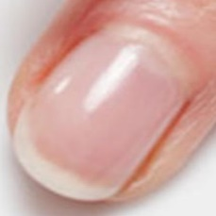  
 normal#1371  
**Analysis by this app:**normal = 98%; non-serious = 1%; check with a GP = 1%;   
The nail's condition is normal with confidence score of 98%.  
Otherwise it is non-serious with confidence score of 1%.×

 normal#186  
**Analysis by this app:**normal = 98%; non-serious = 1%; check with a GP = 1%;   
The nail's condition is normal with confidence score of 98%.  
Otherwise it is non-serious with confidence score of 1%.×

 normal#926  
**Analysis by this app:**normal = 98%; non-serious = 0%; check with a GP = 2%;   
The nail's condition is normal with confidence score of 98%.  
The confidence score for consulting a GP is 2%.×

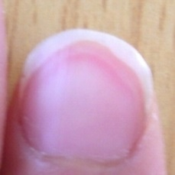  
 normal#1311  
**Analysis by this app:**normal = 98%; non-serious = 0%; check with a GP = 2%;   
The nail's condition is normal with confidence score of 98%.  
The confidence score for consulting a GP is 2%.×

 normal#821  
**Analysis by this app:**normal = 98%; non-serious = 0%; check with a GP = 2%;   
The nail's condition is normal with confidence score of 98%.  
The confidence score for consulting a GP is 2%.×

 normal#941  
**Analysis by this app:**normal = 98%; non-serious = 0%; check with a GP = 2%;   
The nail's condition is normal with confidence score of 98%.  
The confidence score for consulting a GP is 2%.×

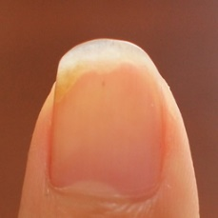  
 normal#1286  
**Analysis by this app:**normal = 98%; non-serious = 1%; check with a GP = 1%;   
The nail's condition is normal with confidence score of 98%.  
Otherwise it is non-serious with confidence score of 1%.×

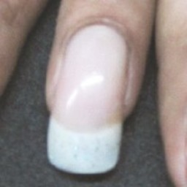  
 normal#1101  
**Analysis by this app:**normal = 98%; non-serious = 1%; check with a GP = 1%;   
The nail's condition is normal with confidence score of 98%.  
Otherwise it is non-serious with confidence score of 1%.×

 normal#121  
**Analysis by this app:**normal = 98%; non-serious = 0%; check with a GP = 2%;   
The nail's condition is normal with confidence score of 98%.  
The confidence score for consulting a GP is 2%.×

 normal#686  
**Analysis by this app:**normal = 98%; non-serious = 1%; check with a GP = 1%;   
The nail's condition is normal with confidence score of 98%.  
Otherwise it is non-serious with confidence score of 1%.×

 normal#801  
**Analysis by this app:**normal = 98%; non-serious = 0%; check with a GP = 2%;   
The nail's condition is normal with confidence score of 98%.  
The confidence score for consulting a GP is 2%.×

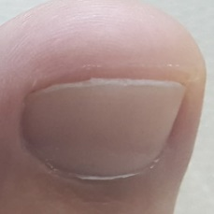  
 normal#1366  
**Analysis by this app:**normal = 98%; non-serious = 1%; check with a GP = 2%;   
The nail's condition is normal with confidence score of 98%.  
The confidence score for consulting a GP is 2%.×

 normal#991  
**Analysis by this app:**normal = 98%; non-serious = 0%; check with a GP = 2%;   
The nail's condition is normal with confidence score of 98%.  
The confidence score for consulting a GP is 2%.×

 normal#151  
**Analysis by this app:**normal = 98%; non-serious = 2%; check with a GP = 0%;   
The nail's condition is normal with confidence score of 98%.  
Otherwise it is non-serious with confidence score of 2%.×

 normal#691  
**Analysis by this app:**normal = 97%; non-serious = 0%; check with a GP = 2%;   
The nail's condition is normal with confidence score of 97%.  
The confidence score for consulting a GP is 2%.×

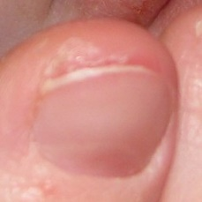  
 normal#1331  
**Analysis by this app:**normal = 97%; non-serious = 1%; check with a GP = 2%;   
The nail's condition is normal with confidence score of 97%.  
The confidence score for consulting a GP is 2%.×

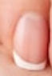  
 normal#1426  
**Analysis by this app:**normal = 97%; non-serious = 0%; check with a GP = 3%;   
The nail's condition is normal with confidence score of 97%.  
The confidence score for consulting a GP is 3%.×

 normal#161  
**Analysis by this app:**normal = 97%; non-serious = 1%; check with a GP = 1%;   
The nail's condition is normal with confidence score of 97%.  
Otherwise it is non-serious with confidence score of 1%.×

 normal#646  
**Analysis by this app:**normal = 97%; non-serious = 3%; check with a GP = 0%;   
The nail's condition is normal with confidence score of 97%.  
Otherwise it is non-serious with confidence score of 3%.×

 normal#466  
**Analysis by this app:**normal = 97%; non-serious = 2%; check with a GP = 1%;   
The nail's condition is normal with confidence score of 97%.  
Otherwise it is non-serious with confidence score of 2%.×

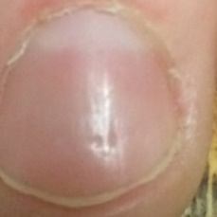  
 normal#1121  
**Analysis by this app:**normal = 97%; non-serious = 0%; check with a GP = 2%;   
The nail's condition is normal with confidence score of 97%.  
The confidence score for consulting a GP is 2%.×

 normal#736  
**Analysis by this app:**normal = 97%; non-serious = 0%; check with a GP = 3%;   
The nail's condition is normal with confidence score of 97%.  
The confidence score for consulting a GP is 3%.×

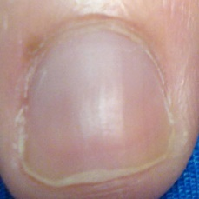  
 normal#1111  
**Analysis by this app:**normal = 97%; non-serious = 1%; check with a GP = 2%;   
The nail's condition is normal with confidence score of 97%.  
The confidence score for consulting a GP is 2%.×

 normal#866  
**Analysis by this app:**normal = 97%; non-serious = 3%; check with a GP = 0%;   
The nail's condition is normal with confidence score of 97%.  
Otherwise it is non-serious with confidence score of 3%.×

 normal#931  
**Analysis by this app:**normal = 97%; non-serious = 0%; check with a GP = 3%;   
The nail's condition is normal with confidence score of 97%.  
The confidence score for consulting a GP is 3%.×

 normal#786  
**Analysis by this app:**normal = 97%; non-serious = 0%; check with a GP = 3%;   
The nail's condition is normal with confidence score of 97%.  
The confidence score for consulting a GP is 3%.×

 normal#581  
**Analysis by this app:**normal = 97%; non-serious = 0%; check with a GP = 3%;   
The nail's condition is normal with confidence score of 97%.  
The confidence score for consulting a GP is 3%.×

 normal#181  
**Analysis by this app:**normal = 97%; non-serious = 0%; check with a GP = 3%;   
The nail's condition is normal with confidence score of 97%.  
The confidence score for consulting a GP is 3%.×

 normal#141  
**Analysis by this app:**normal = 97%; non-serious = 1%; check with a GP = 2%;   
The nail's condition is normal with confidence score of 97%.  
The confidence score for consulting a GP is 2%.×

 normal#706  
**Analysis by this app:**normal = 97%; non-serious = 0%; check with a GP = 3%;   
The nail's condition is normal with confidence score of 97%.  
The confidence score for consulting a GP is 3%.×

 normal#491  
**Analysis by this app:**normal = 97%; non-serious = 0%; check with a GP = 3%;   
The nail's condition is normal with confidence score of 97%.  
The confidence score for consulting a GP is 3%.×

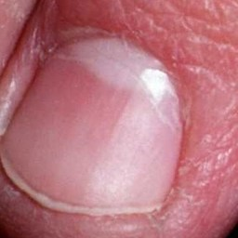  
 normal#1016  
**Analysis by this app:**normal = 96%; non-serious = 0%; check with a GP = 3%;   
The nail's condition is normal with confidence score of 96%.  
The confidence score for consulting a GP is 3%.×

 normal#631  
**Analysis by this app:**normal = 96%; non-serious = 2%; check with a GP = 1%;   
The nail's condition is normal with confidence score of 96%.  
Otherwise it is non-serious with confidence score of 2%.×

 normal#966  
**Analysis by this app:**normal = 96%; non-serious = 0%; check with a GP = 4%;   
The nail's condition is normal with confidence score of 96%.  
The confidence score for consulting a GP is 4%.×

 normal#31  
**Analysis by this app:**normal = 96%; non-serious = 1%; check with a GP = 3%;   
The nail's condition is normal with confidence score of 96%.  
The confidence score for consulting a GP is 3%.×

 normal#876  
**Analysis by this app:**normal = 96%; non-serious = 3%; check with a GP = 1%;   
The nail's condition is normal with confidence score of 96%.  
Otherwise it is non-serious with confidence score of 3%.×

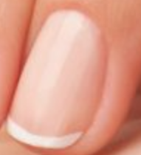  
 normal#1391  
**Analysis by this app:**normal = 96%; non-serious = 1%; check with a GP = 4%;   
The nail's condition is normal with confidence score of 96%.  
The confidence score for consulting a GP is 4%.×

 normal#281  
**Analysis by this app:**normal = 96%; non-serious = 1%; check with a GP = 4%;   
The nail's condition is normal with confidence score of 96%.  
The confidence score for consulting a GP is 4%.×

 normal#21  
**Analysis by this app:**normal = 96%; non-serious = 3%; check with a GP = 1%;   
The nail's condition is normal with confidence score of 96%.  
Otherwise it is non-serious with confidence score of 3%.×

 normal#911  
**Analysis by this app:**normal = 96%; non-serious = 1%; check with a GP = 3%;   
The nail's condition is normal with confidence score of 96%.  
The confidence score for consulting a GP is 3%.×

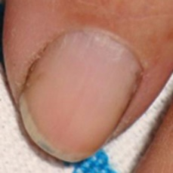  
 normal#1246  
**Analysis by this app:**normal = 95%; non-serious = 3%; check with a GP = 2%;   
The nail's condition is normal with confidence score of 95%.  
Otherwise it is non-serious with confidence score of 3%.×

 normal#446  
**Analysis by this app:**normal = 95%; non-serious = 1%; check with a GP = 4%;   
The nail's condition is normal with confidence score of 95%.  
The confidence score for consulting a GP is 4%.×

 normal#896  
**Analysis by this app:**normal = 95%; non-serious = 0%; check with a GP = 4%;   
The nail's condition is normal with confidence score of 95%.  
The confidence score for consulting a GP is 4%.×

 normal#321  
**Analysis by this app:**normal = 95%; non-serious = 0%; check with a GP = 4%;   
The nail's condition is normal with confidence score of 95%.  
The confidence score for consulting a GP is 4%.×

 normal#46  
**Analysis by this app:**normal = 95%; non-serious = 1%; check with a GP = 4%;   
The nail's condition is normal with confidence score of 95%.  
The confidence score for consulting a GP is 4%.×

 normal#816  
**Analysis by this app:**normal = 95%; non-serious = 0%; check with a GP = 5%;   
The nail's condition is normal with confidence score of 95%.  
The confidence score for consulting a GP is 5%.×

http://localhost:8080/ai/onyx/images/normal/Fingernail%20healthy%20Image_14d.png  
 normal#1386  
**Analysis by this app:**normal = 95%; non-serious = 1%; check with a GP = 4%;   
The nail's condition is normal with confidence score of 95%.  
The confidence score for consulting a GP is 4%.×

 normal#841  
**Analysis by this app:**normal = 95%; non-serious = 3%; check with a GP = 2%;   
The nail's condition is normal with confidence score of 95%.  
Otherwise it is non-serious with confidence score of 3%.×

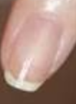  
 normal#1406  
**Analysis by this app:**normal = 95%; non-serious = 4%; check with a GP = 1%;   
The nail's condition is normal with confidence score of 95%.  
Otherwise it is non-serious with confidence score of 4%.×

 normal#221  
**Analysis by this app:**normal = 95%; non-serious = 3%; check with a GP = 2%;   
The nail's condition is normal with confidence score of 95%.  
Otherwise it is non-serious with confidence score of 3%.×

 normal#636  
**Analysis by this app:**normal = 95%; non-serious = 1%; check with a GP = 4%;   
The nail's condition is normal with confidence score of 95%.  
The confidence score for consulting a GP is 4%.×

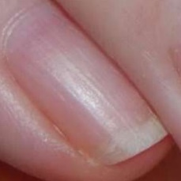  
 normal#1421  
**Analysis by this app:**normal = 95%; non-serious = 2%; check with a GP = 3%;   
The nail's condition is normal with confidence score of 95%.  
The confidence score for consulting a GP is 3%.×

 normal#666  
**Analysis by this app:**normal = 95%; non-serious = 0%; check with a GP = 5%;   
The nail's condition is normal with confidence score of 95%.  
The confidence score for consulting a GP is 5%.×

 normal#496  
**Analysis by this app:**normal = 95%; non-serious = 0%; check with a GP = 5%;   
The nail's condition is normal with confidence score of 95%.  
The confidence score for consulting a GP is 5%.×

 normal#386  
**Analysis by this app:**normal = 95%; non-serious = 1%; check with a GP = 4%;   
The nail's condition is normal with confidence score of 95%.  
The confidence score for consulting a GP is 4%.×

 normal#501  
**Analysis by this app:**normal = 95%; non-serious = 1%; check with a GP = 4%;   
The nail's condition is normal with confidence score of 95%.  
The confidence score for consulting a GP is 4%.×

 normal#36  
**Analysis by this app:**normal = 95%; non-serious = 0%; check with a GP = 5%;   
The nail's condition is normal with confidence score of 95%.  
The confidence score for consulting a GP is 5%.×

 normal#611  
**Analysis by this app:**normal = 95%; non-serious = 2%; check with a GP = 3%;   
The nail's condition is normal with confidence score of 95%.  
The confidence score for consulting a GP is 3%.×

 normal#556  
**Analysis by this app:**normal = 95%; non-serious = 0%; check with a GP = 5%;   
The nail's condition is normal with confidence score of 95%.  
The confidence score for consulting a GP is 5%.×

 normal#901  
**Analysis by this app:**normal = 94%; non-serious = 0%; check with a GP = 5%;   
The nail's condition is normal with confidence score of 94%.  
The confidence score for consulting a GP is 5%.×

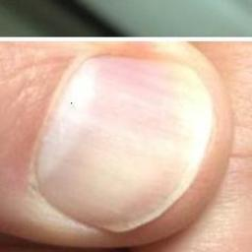  
 normal#1201  
**Analysis by this app:**normal = 94%; non-serious = 1%; check with a GP = 5%;   
The nail's condition is normal with confidence score of 94%.  
The confidence score for consulting a GP is 5%.×

  
 normal#1036  
**Analysis by this app:**normal = 94%; non-serious = 1%; check with a GP = 5%;   
The nail's condition is normal with confidence score of 94%.  
The confidence score for consulting a GP is 5%.×

 normal#266  
**Analysis by this app:**normal = 94%; non-serious = 0%; check with a GP = 5%;   
The nail's condition is normal with confidence score of 94%.  
The confidence score for consulting a GP is 5%.×

 normal#376  
**Analysis by this app:**normal = 94%; non-serious = 0%; check with a GP = 6%;   
The nail's condition is normal with confidence score of 94%.  
The confidence score for consulting a GP is 6%.×

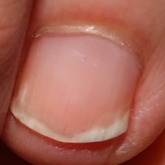  
 normal#1141  
**Analysis by this app:**normal = 94%; non-serious = 0%; check with a GP = 6%;   
The nail's condition is normal with confidence score of 94%.  
The confidence score for consulting a GP is 6%.×

 normal#261  
**Analysis by this app:**normal = 94%; non-serious = 1%; check with a GP = 5%;   
The nail's condition is normal with confidence score of 94%.  
The confidence score for consulting a GP is 5%.×

 normal#56  
**Analysis by this app:**normal = 94%; non-serious = 0%; check with a GP = 6%;   
The nail's condition is normal with confidence score of 94%.  
The confidence score for consulting a GP is 6%.×

 normal#361  
**Analysis by this app:**normal = 94%; non-serious = 2%; check with a GP = 4%;   
The nail's condition is normal with confidence score of 94%.  
The confidence score for consulting a GP is 4%.×

 normal#946  
**Analysis by this app:**normal = 93%; non-serious = 5%; check with a GP = 2%;   
The nail's condition is normal with confidence score of 93%.  
Otherwise it is non-serious with confidence score of 5%.×

 normal#616  
**Analysis by this app:**normal = 93%; non-serious = 0%; check with a GP = 6%;   
The nail's condition is normal with confidence score of 93%.  
The confidence score for consulting a GP is 6%.×

 normal#881  
**Analysis by this app:**normal = 93%; non-serious = 5%; check with a GP = 2%;   
The nail's condition is normal with confidence score of 93%.  
Otherwise it is non-serious with confidence score of 5%.×

 normal#411  
**Analysis by this app:**normal = 93%; non-serious = 2%; check with a GP = 5%;   
The nail's condition is normal with confidence score of 93%.  
The confidence score for consulting a GP is 5%.×

 normal#906  
**Analysis by this app:**normal = 93%; non-serious = 6%; check with a GP = 1%;   
The nail's condition is normal with confidence score of 93%.  
Otherwise it is non-serious with confidence score of 6%.×

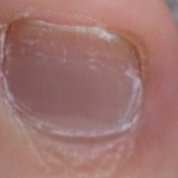  
 normal#1301  
**Analysis by this app:**normal = 92%; non-serious = 4%; check with a GP = 4%;   
The nail's condition is normal with confidence score of 92%.  
Otherwise it is non-serious with confidence score of 4%.×

 normal#621  
**Analysis by this app:**normal = 92%; non-serious = 0%; check with a GP = 7%;   
The nail's condition is normal with confidence score of 92%.  
The confidence score for consulting a GP is 7%.×

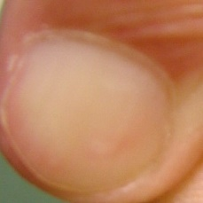  
 normal#1071  
**Analysis by this app:**normal = 92%; non-serious = 0%; check with a GP = 7%;   
The nail's condition is normal with confidence score of 92%.  
The confidence score for consulting a GP is 7%.×

 normal#346  
**Analysis by this app:**normal = 92%; non-serious = 1%; check with a GP = 7%;   
The nail's condition is normal with confidence score of 92%.  
The confidence score for consulting a GP is 7%.×

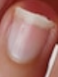  
 normal#1416  
**Analysis by this app:**normal = 92%; non-serious = 3%; check with a GP = 5%;   
The nail's condition is normal with confidence score of 92%.  
The confidence score for consulting a GP is 5%.×

 normal#211  
**Analysis by this app:**normal = 92%; non-serious = 0%; check with a GP = 8%;   
The nail's condition is normal with confidence score of 92%.  
The confidence score for consulting a GP is 8%.×

 normal#316  
**Analysis by this app:**normal = 92%; non-serious = 6%; check with a GP = 2%;   
The nail's condition is normal with confidence score of 92%.  
Otherwise it is non-serious with confidence score of 6%.×

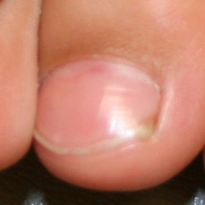  
 normal#1206  
**Analysis by this app:**normal = 91%; non-serious = 1%; check with a GP = 8%;   
The nail's condition is normal with confidence score of 91%.  
The confidence score for consulting a GP is 8%.×

  
 normal#1041  
**Analysis by this app:**normal = 91%; non-serious = 1%; check with a GP = 8%;   
The nail's condition is normal with confidence score of 91%.  
The confidence score for consulting a GP is 8%.×

 normal#476  
**Analysis by this app:**normal = 91%; non-serious = 6%; check with a GP = 3%;   
The nail's condition is normal with confidence score of 91%.  
Otherwise it is non-serious with confidence score of 6%.×

 normal#431  
**Analysis by this app:**normal = 91%; non-serious = 7%; check with a GP = 2%;   
The nail's condition is normal with confidence score of 91%.  
Otherwise it is non-serious with confidence score of 7%.×

 normal#561  
**Analysis by this app:**normal = 91%; non-serious = 1%; check with a GP = 8%;   
The nail's condition is normal with confidence score of 91%.  
The confidence score for consulting a GP is 8%.×

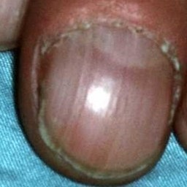  
 normal#1106  
**Analysis by this app:**normal = 91%; non-serious = 3%; check with a GP = 7%;   
The nail's condition is normal with confidence score of 91%.  
The confidence score for consulting a GP is 7%.×

 normal#671  
**Analysis by this app:**normal = 91%; non-serious = 0%; check with a GP = 9%;   
The nail's condition is normal with confidence score of 91%.  
The confidence score for consulting a GP is 9%.×

 normal#656  
**Analysis by this app:**normal = 91%; non-serious = 7%; check with a GP = 2%;   
The nail's condition is normal with confidence score of 91%.  
Otherwise it is non-serious with confidence score of 7%.×

 normal#96  
**Analysis by this app:**normal = 91%; non-serious = 2%; check with a GP = 7%;   
The nail's condition is normal with confidence score of 91%.  
The confidence score for consulting a GP is 7%.×

 normal#81  
**Analysis by this app:**normal = 91%; non-serious = 1%; check with a GP = 8%;   
The nail's condition is normal with confidence score of 91%.  
The confidence score for consulting a GP is 8%.×

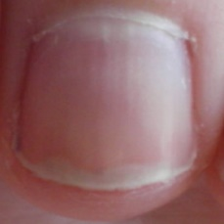  
 normal#1376  
**Analysis by this app:**normal = 90%; non-serious = 0%; check with a GP = 9%;   
The nail's condition is normal with confidence score of 90%.  
The confidence score for consulting a GP is 9%.×

 normal#596  
**Analysis by this app:**normal = 90%; non-serious = 9%; check with a GP = 1%;   
The nail's condition is normal with confidence score of 90%.  
Otherwise it is non-serious with confidence score of 9%.×

 normal#311  
**Analysis by this app:**normal = 90%; non-serious = 7%; check with a GP = 2%;   
The nail's condition is normal with confidence score of 90%.  
Otherwise it is non-serious with confidence score of 7%.×

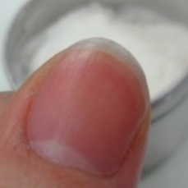  
 normal#1356  
**Analysis by this app:**normal = 90%; non-serious = 1%; check with a GP = 9%;   
The nail's condition is normal with confidence score of 90%.  
The confidence score for consulting a GP is 9%.×

 normal#831  
**Analysis by this app:**normal = 90%; non-serious = 1%; check with a GP = 9%;   
The nail's condition is normal with confidence score of 90%.  
The confidence score for consulting a GP is 9%.×

 normal#591  
**Analysis by this app:**normal = 90%; non-serious = 7%; check with a GP = 3%;   
The nail's condition is normal with confidence score of 90%.  
Otherwise it is non-serious with confidence score of 7%.×

 normal#771  
**Analysis by this app:**normal = 90%; non-serious = 0%; check with a GP = 10%;   
The nail's condition is normal with confidence score of 90%.  
The confidence score for consulting a GP is 10%.×

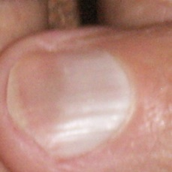  
 normal#1236  
**Analysis by this app:**normal = 90%; non-serious = 1%; check with a GP = 10%;   
The nail's condition is normal with confidence score of 90%.  
The confidence score for consulting a GP is 10%.×

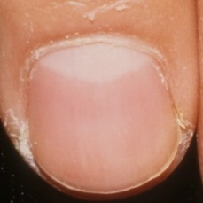  
 normal#1006  
**Analysis by this app:**normal = 90%; non-serious = 1%; check with a GP = 10%;   
The nail's condition is normal with confidence score of 90%.  
The confidence score for consulting a GP is 10%.×

 normal#366  
**Analysis by this app:**normal = 89%; non-serious = 7%; check with a GP = 4%;   
The nail's condition is normal with confidence score of 89%.  
Otherwise it is non-serious with confidence score of 7%.×

 normal#406  
**Analysis by this app:**normal = 89%; non-serious = 4%; check with a GP = 7%;   
The nail's condition is normal with confidence score of 89%.  
The confidence score for consulting a GP is 7%.×

 normal#471  
**Analysis by this app:**normal = 89%; non-serious = 1%; check with a GP = 10%;   
The nail's condition is normal with confidence score of 89%.  
The confidence score for consulting a GP is 10%.×

 normal#856  
**Analysis by this app:**normal = 89%; non-serious = 6%; check with a GP = 5%;   
The nail's condition is normal with confidence score of 89%.  
Otherwise it is non-serious with confidence score of 6%.×

 normal#246  
**Analysis by this app:**normal = 88%; non-serious = 2%; check with a GP = 10%;   
The nail's condition is normal with confidence score of 88%.  
The confidence score for consulting a GP is 10%.×

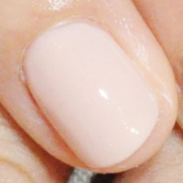  
 normal#1296  
**Analysis by this app:**normal = 87%; non-serious = 2%; check with a GP = 11%;   
The nail's condition is normal with confidence score of 87%.  
The confidence score for consulting a GP is 11%.×

 normal#536  
**Analysis by this app:**normal = 87%; non-serious = 1%; check with a GP = 12%;   
The nail's condition is normal with confidence score of 87%.  
The confidence score for consulting a GP is 12%.×

 normal#126  
**Analysis by this app:**normal = 87%; non-serious = 4%; check with a GP = 9%;   
The nail's condition is normal with confidence score of 87%.  
The confidence score for consulting a GP is 9%.×

 normal#436  
**Analysis by this app:**normal = 86%; non-serious = 5%; check with a GP = 8%;   
The nail's condition is normal with confidence score of 86%.  
The confidence score for consulting a GP is 8%.×

 normal#156  
**Analysis by this app:**normal = 86%; non-serious = 11%; check with a GP = 3%;   
The nail's condition is normal with confidence score of 86%.  
Otherwise it is non-serious with confidence score of 11%.×

 normal#846  
**Analysis by this app:**normal = 86%; non-serious = 12%; check with a GP = 3%;   
The nail's condition is normal with confidence score of 86%.  
Otherwise it is non-serious with confidence score of 12%.×

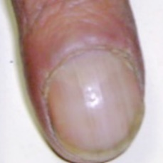  
 normal#1091  
**Analysis by this app:**normal = 86%; non-serious = 3%; check with a GP = 11%;   
The nail's condition is normal with confidence score of 86%.  
The confidence score for consulting a GP is 11%.×

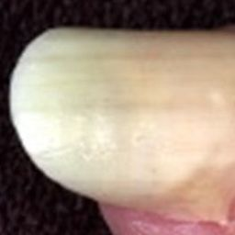  
 normal#1046  
**Analysis by this app:**normal = 85%; non-serious = 10%; check with a GP = 5%;   
The nail's condition is normal with confidence score of 85%.  
Otherwise it is non-serious with confidence score of 10%.×

 normal#676  
**Analysis by this app:**normal = 85%; non-serious = 2%; check with a GP = 12%;   
The nail's condition is normal with confidence score of 85%.  
The confidence score for consulting a GP is 12%.×

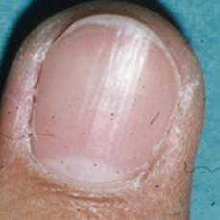  
 normal#1186  
**Analysis by this app:**normal = 85%; non-serious = 0%; check with a GP = 15%;   
The nail's condition is normal with confidence score of 85%.  
The confidence score for consulting a GP is 15%.×

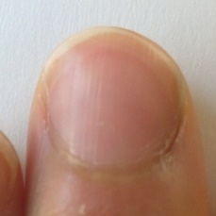  
 normal#1306  
**Analysis by this app:**normal = 85%; non-serious = 0%; check with a GP = 15%;   
The nail's condition is normal with confidence score of 85%.  
The confidence score for consulting a GP is 15%.×

 normal#826  
**Analysis by this app:**normal = 84%; non-serious = 10%; check with a GP = 6%;   
The nail's condition is normal with confidence score of 84%.  
Otherwise it is non-serious with confidence score of 10%.×

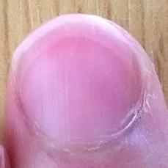  
 normal#1281  
**Analysis by this app:**normal = 84%; non-serious = 0%; check with a GP = 16%;   
The nail's condition is normal with confidence score of 84%.  
The confidence score for consulting a GP is 16%.×

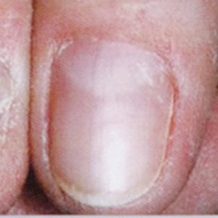  
 normal#1326  
**Analysis by this app:**normal = 84%; non-serious = 12%; check with a GP = 4%;   
The nail's condition is normal with confidence score of 84%.  
Otherwise it is non-serious with confidence score of 12%.×

 normal#91  
**Analysis by this app:**normal = 83%; non-serious = 10%; check with a GP = 8%;   
The nail's condition is normal with confidence score of 83%.  
Otherwise it is non-serious with confidence score of 10%.×

 normal#291  
**Analysis by this app:**normal = 83%; non-serious = 12%; check with a GP = 5%;   
The nail's condition is normal with confidence score of 83%.  
Otherwise it is non-serious with confidence score of 12%.×

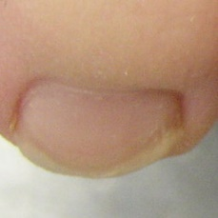  
 normal#1226  
**Analysis by this app:**normal = 82%; non-serious = 14%; check with a GP = 3%;   
The nail's condition is normal with confidence score of 82%.  
Otherwise it is non-serious with confidence score of 14%.×

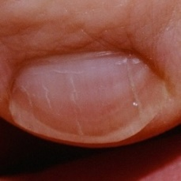  
 normal#1076  
**Analysis by this app:**normal = 82%; non-serious = 11%; check with a GP = 7%;   
The nail's condition is normal with confidence score of 82%.  
Otherwise it is non-serious with confidence score of 11%.×

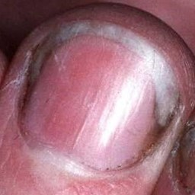  
 normal#1251  
**Analysis by this app:**normal = 82%; non-serious = 5%; check with a GP = 13%;   
The nail's condition is normal with confidence score of 82%.  
The confidence score for consulting a GP is 13%.×

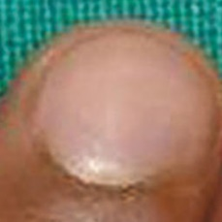  
 normal#1241  
**Analysis by this app:**normal = 82%; non-serious = 3%; check with a GP = 15%;   
The nail's condition is normal with confidence score of 82%.  
The confidence score for consulting a GP is 15%.×

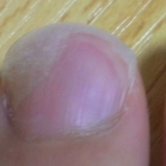  
 normal#1321  
**Analysis by this app:**normal = 81%; non-serious = 19%; check with a GP = 0%;   
The nail's condition is normal with confidence score of 81%.  
Otherwise it is non-serious with confidence score of 19%.×

 normal#641  
**Analysis by this app:**normal = 81%; non-serious = 0%; check with a GP = 19%;   
The nail's condition is normal with confidence score of 81%.  
The confidence score for consulting a GP is 19%.×

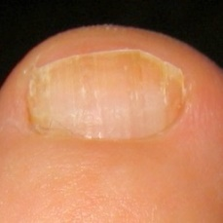  
 normal#1056  
**Analysis by this app:**normal = 80%; non-serious = 18%; check with a GP = 2%;   
The nail's condition is normal with confidence score of 80%.  
Otherwise it is non-serious with confidence score of 18%.×

 normal#251  
**Analysis by this app:**normal = 80%; non-serious = 0%; check with a GP = 20%;   
Perhaps a GP should be consulted (confidence score is 20%) ×

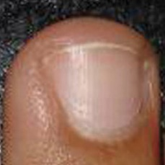  
 normal#1061  
**Analysis by this app:**normal = 80%; non-serious = 3%; check with a GP = 17%;   
The nail's condition is normal with confidence score of 80%.  
The confidence score for consulting a GP is 17%.×

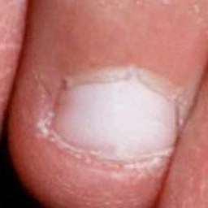  
 normal#1271  
**Analysis by this app:**normal = 80%; non-serious = 20%; check with a GP = 0%;   
The nail's condition is normal with confidence score of 80%.  
Otherwise it is non-serious with confidence score of 20%.×

 normal#421  
**Analysis by this app:**normal = 79%; non-serious = 21%; check with a GP = 0%;   
The nail's condition is normal with confidence score of 79%.  
Otherwise it is non-serious with confidence score of 21%.×

 normal#101  
**Analysis by this app:**normal = 79%; non-serious = 16%; check with a GP = 5%;   
The nail's condition is normal with confidence score of 79%.  
Otherwise it is non-serious with confidence score of 16%.×

 normal#441  
**Analysis by this app:**normal = 79%; non-serious = 5%; check with a GP = 17%;   
The nail's condition is normal with confidence score of 79%.  
The confidence score for consulting a GP is 17%.×

 normal#781  
**Analysis by this app:**normal = 79%; non-serious = 1%; check with a GP = 20%;   
Perhaps a GP should be consulted (confidence score is 20%) ×

 normal#201  
**Analysis by this app:**normal = 76%; non-serious = 0%; check with a GP = 24%;   
Perhaps a GP should be consulted (confidence score is 24%) ×

 normal#326  
**Analysis by this app:**normal = 76%; non-serious = 22%; check with a GP = 3%;   
The nail's condition is normal with confidence score of 76%.  
Otherwise it is non-serious with confidence score of 22%.×

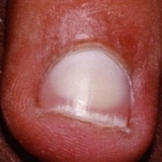  
 normal#1256  
**Analysis by this app:**normal = 75%; non-serious = 16%; check with a GP = 9%;   
The nail's condition is normal with confidence score of 75%.  
Otherwise it is non-serious with confidence score of 16%.×

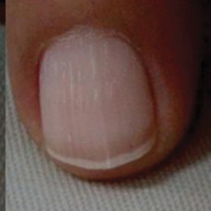  
 normal#1176  
**Analysis by this app:**normal = 75%; non-serious = 7%; check with a GP = 18%;   
The nail's condition is normal with confidence score of 75%.  
The confidence score for consulting a GP is 18%.×

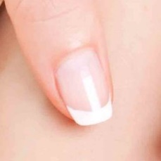  
 normal#1341  
**Analysis by this app:**normal = 74%; non-serious = 10%; check with a GP = 16%;   
The nail's condition is normal with confidence score of 74%.  
The confidence score for consulting a GP is 16%.×

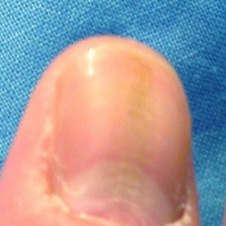  
 normal#1096  
**Analysis by this app:**normal = 74%; non-serious = 18%; check with a GP = 8%;   
The nail's condition is normal with confidence score of 74%.  
Otherwise it is non-serious with confidence score of 18%.×

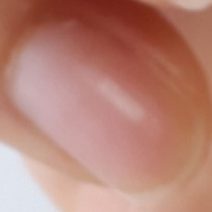  
 normal#1361  
**Analysis by this app:**normal = 74%; non-serious = 1%; check with a GP = 26%;   
Perhaps a GP should be consulted (confidence score is 26%) ×

 normal#506  
**Analysis by this app:**normal = 74%; non-serious = 3%; check with a GP = 24%;   
Perhaps a GP should be consulted (confidence score is 24%) ×

 normal#711  
**Analysis by this app:**normal = 73%; non-serious = 2%; check with a GP = 25%;   
Perhaps a GP should be consulted (confidence score is 25%) ×

 normal#546  
**Analysis by this app:**normal = 73%; non-serious = 13%; check with a GP = 14%;   
The nail's condition is normal with confidence score of 73%.  
The confidence score for consulting a GP is 14%.×

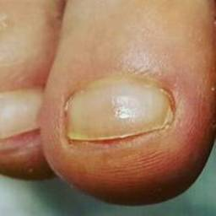  
 normal#1346  
**Analysis by this app:**normal = 72%; non-serious = 24%; check with a GP = 3%;   
The nail's condition is normal with confidence score of 72%.  
Otherwise it is non-serious with confidence score of 24%.×

 normal#601  
**Analysis by this app:**normal = 72%; non-serious = 0%; check with a GP = 28%;   
Perhaps a GP should be consulted (confidence score is 28%) ×

 normal#51  
**Analysis by this app:**normal = 72%; non-serious = 27%; check with a GP = 2%;   
The nail's condition is normal with confidence score of 72%.  
Otherwise it is non-serious with confidence score of 27%.×

 normal#166  
**Analysis by this app:**normal = 71%; non-serious = 3%; check with a GP = 26%;   
Perhaps a GP should be consulted (confidence score is 26%) ×

 normal#516  
**Analysis by this app:**normal = 71%; non-serious = 0%; check with a GP = 29%;   
Perhaps a GP should be consulted (confidence score is 29%) ×

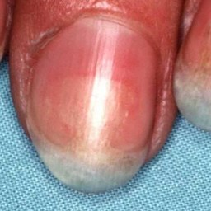  
 normal#1151  
**Analysis by this app:**normal = 70%; non-serious = 1%; check with a GP = 28%;   
Perhaps a GP should be consulted (confidence score is 28%) ×

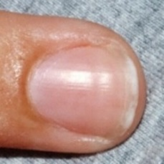  
 normal#1086  
**Analysis by this app:**normal = 70%; non-serious = 1%; check with a GP = 28%;   
Perhaps a GP should be consulted (confidence score is 28%) ×

 normal#371  
**Analysis by this app:**normal = 70%; non-serious = 13%; check with a GP = 18%;   
The nail's condition is normal with confidence score of 70%.  
The confidence score for consulting a GP is 18%.×

 normal#541  
**Analysis by this app:**normal = 70%; non-serious = 4%; check with a GP = 26%;   
Perhaps a GP should be consulted (confidence score is 26%) ×

 normal#456  
**Analysis by this app:**normal = 70%; non-serious = 2%; check with a GP = 28%;   
Perhaps a GP should be consulted (confidence score is 28%) ×

 normal#796  
**Analysis by this app:**normal = 67%; non-serious = 31%; check with a GP = 2%;   
The nail's condition is normal with confidence score of 67%.  
Otherwise it is non-serious with confidence score of 31%.×

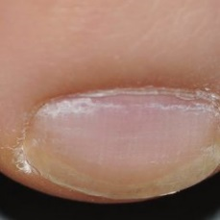  
 normal#1336  
**Analysis by this app:**normal = 67%; non-serious = 15%; check with a GP = 18%;   
The nail's condition is normal with confidence score of 67%.  
The confidence score for consulting a GP is 18%.×

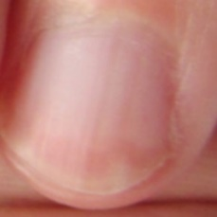  
 normal#1411  
**Analysis by this app:**normal = 66%; non-serious = 0%; check with a GP = 34%;   
Perhaps a GP should be consulted (confidence score is 34%) ×

 normal#861  
**Analysis by this app:**normal = 65%; non-serious = 5%; check with a GP = 30%;   
Perhaps a GP should be consulted (confidence score is 30%) ×

 normal#971  
**Analysis by this app:**normal = 62%; non-serious = 37%; check with a GP = 0%;   
The nail's condition is normal with confidence score of 62%.  
Otherwise it is non-serious with confidence score of 37%.×

 normal#566  
**Analysis by this app:**normal = 62%; non-serious = 1%; check with a GP = 37%;   
Perhaps a GP should be consulted (confidence score is 37%) ×

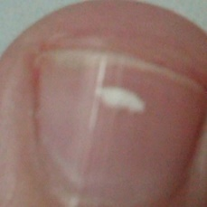  
 normal#1166  
**Analysis by this app:**normal = 62%; non-serious = 28%; check with a GP = 10%;   
The nail's condition is normal with confidence score of 62%.  
Otherwise it is non-serious with confidence score of 28%.×

 normal#136  
**Analysis by this app:**normal = 61%; non-serious = 11%; check with a GP = 28%;   
Perhaps a GP should be consulted (confidence score is 28%) ×

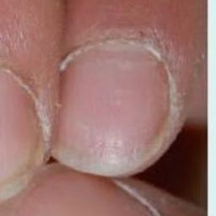  
 normal#1216  
**Analysis by this app:**normal = 61%; non-serious = 21%; check with a GP = 18%;   
The nail's condition is normal with confidence score of 61%.  
Otherwise it is non-serious with confidence score of 21%.×

 normal#146  
**Analysis by this app:**normal = 61%; non-serious = 29%; check with a GP = 10%;   
The nail's condition is normal with confidence score of 61%.  
Otherwise it is non-serious with confidence score of 29%.×

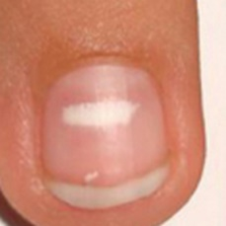  
 normal#1276  
**Analysis by this app:**normal = 60%; non-serious = 14%; check with a GP = 27%;   
Perhaps a GP should be consulted (confidence score is 27%) ×

 normal#286  
**Analysis by this app:**normal = 59%; non-serious = 3%; check with a GP = 37%;   
Not very sure whether the nail is OK or not. Sorry.×

 normal#961  
**Analysis by this app:**normal = 58%; non-serious = 28%; check with a GP = 13%;   
Not very sure whether the nail is OK or not. Sorry.×

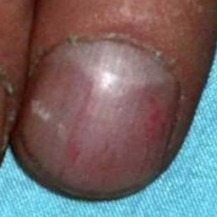  
 normal#1221  
**Analysis by this app:**normal = 57%; non-serious = 33%; check with a GP = 10%;   
Not very sure whether the nail is OK or not. Sorry.×

 normal#606  
**Analysis by this app:**normal = 57%; non-serious = 0%; check with a GP = 43%;   
Not very sure whether the nail is OK or not. Sorry.×

 normal#871  
**Analysis by this app:**normal = 56%; non-serious = 4%; check with a GP = 40%;   
Not very sure whether the nail is OK or not. Sorry.×

 normal#661  
**Analysis by this app:**normal = 55%; non-serious = 0%; check with a GP = 45%;   
Not very sure whether the nail is OK or not. Sorry.×

 normal#296  
**Analysis by this app:**normal = 54%; non-serious = 6%; check with a GP = 41%;   
Not very sure whether the nail is OK or not. Sorry.×

 normal#206  
**Analysis by this app:**normal = 53%; non-serious = 46%; check with a GP = 1%;   
Not very sure whether the nail is OK or not. Sorry.×

 normal#191  
**Analysis by this app:**normal = 53%; non-serious = 1%; check with a GP = 46%;   
Not very sure whether the nail is OK or not. Sorry.×

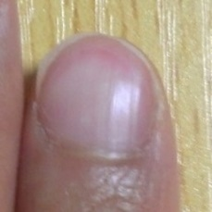  
 normal#1316  
**Analysis by this app:**normal = 52%; non-serious = 5%; check with a GP = 44%;   
Not very sure whether the nail is OK or not. Sorry.×

 normal#196  
**Analysis by this app:**normal = 51%; non-serious = 11%; check with a GP = 38%;   
Not very sure whether the nail is OK or not. Sorry.×

 normal#936  
**Analysis by this app:**normal = 50%; non-serious = 8%; check with a GP = 41%;   
Not very sure whether the nail is OK or not. Sorry.×

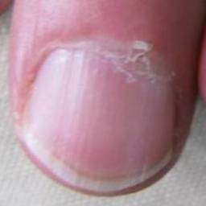  
 normal#1116  
**Analysis by this app:**normal = 50%; non-serious = 1%; check with a GP = 49%;   
Not very sure whether the nail is OK or not. Sorry.×

 normal#41  
**Analysis by this app:**normal = 50%; non-serious = 4%; check with a GP = 47%;   
Not very sure whether the nail is OK or not. Sorry.×

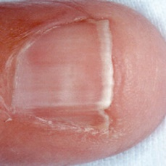  
 normal#1156  
**Analysis by this app:**normal = 48%; non-serious = 6%; check with a GP = 46%;   
Not very sure whether the nail is OK or not. Sorry.×

 normal#216  
**Analysis by this app:**normal = 43%; non-serious = 50%; check with a GP = 7%;   
Not very sure whether the nail is OK or not. Sorry.×

 normal#306  
**Analysis by this app:**normal = 42%; non-serious = 12%; check with a GP = 46%;   
Not very sure whether the nail is OK or not. Sorry.×

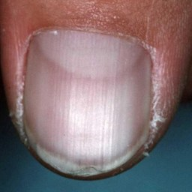  
 normal#1211  
**Analysis by this app:**normal = 42%; non-serious = 2%; check with a GP = 56%;   
Not very sure whether the nail is OK or not. Sorry.×

 normal#891  
**Analysis by this app:**normal = 40%; non-serious = 0%; check with a GP = 60%;   
It is most likely that the nail indicates something that warrants a second opinion and you should seek medical advice. (Confidence score is 60%)×

 normal#851  
**Analysis by this app:**normal = 39%; non-serious = 60%; check with a GP = 2%;   
The nail's condition is non-serious with confidence score of 60%.  
Otherwise it is normal with confidence score of 39%.×

 normal#271  
**Analysis by this app:**normal = 38%; non-serious = 7%; check with a GP = 55%;   
Not very sure whether the nail is OK or not. Sorry.×

 normal#681  
**Analysis by this app:**normal = 38%; non-serious = 61%; check with a GP = 1%;   
The nail's condition is non-serious with confidence score of 61%.  
Otherwise it is normal with confidence score of 38%.×

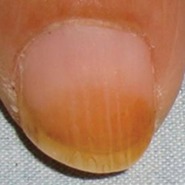  
 normal#1231  
**Analysis by this app:**normal = 38%; non-serious = 1%; check with a GP = 61%;   
It is most likely that the nail indicates something that warrants a second opinion and you should seek medical advice. (Confidence score is 61%)×

 normal#586  
**Analysis by this app:**normal = 36%; non-serious = 27%; check with a GP = 36%;   
Not very sure whether the nail is OK or not. Sorry.×

 normal#86  
**Analysis by this app:**normal = 35%; non-serious = 21%; check with a GP = 43%;   
Not very sure whether the nail is OK or not. Sorry.×

 normal#921  
**Analysis by this app:**normal = 34%; non-serious = 1%; check with a GP = 66%;   
It is most likely that the nail indicates something that warrants a second opinion and you should seek medical advice. (Confidence score is 66%)×

 normal#416  
**Analysis by this app:**normal = 32%; non-serious = 3%; check with a GP = 64%;   
It is most likely that the nail indicates something that warrants a second opinion and you should seek medical advice. (Confidence score is 64%)×

 normal#746  
**Analysis by this app:**normal = 31%; non-serious = 27%; check with a GP = 42%;   
Not very sure whether the nail is OK or not. Sorry.×

 normal#351  
**Analysis by this app:**normal = 31%; non-serious = 5%; check with a GP = 64%;   
It is most likely that the nail indicates something that warrants a second opinion and you should seek medical advice. (Confidence score is 64%)×

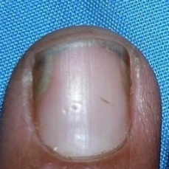  
 normal#1146  
**Analysis by this app:**normal = 31%; non-serious = 3%; check with a GP = 66%;   
It is most likely that the nail indicates something that warrants a second opinion and you should seek medical advice. (Confidence score is 66%)×

  
 normal#1031  
**Analysis by this app:**normal = 31%; non-serious = 3%; check with a GP = 66%;   
It is most likely that the nail indicates something that warrants a second opinion and you should seek medical advice. (Confidence score is 66%)×

 normal#766  
**Analysis by this app:**normal = 31%; non-serious = 0%; check with a GP = 69%;   
It is most likely that the nail indicates something that warrants a second opinion and you should seek medical advice. (Confidence score is 69%)×

 normal#341  
**Analysis by this app:**normal = 30%; non-serious = 2%; check with a GP = 68%;   
It is most likely that the nail indicates something that warrants a second opinion and you should seek medical advice. (Confidence score is 68%)×

 normal#696  
**Analysis by this app:**normal = 26%; non-serious = 0%; check with a GP = 73%;   
It is most likely that the nail indicates something that warrants a second opinion and you should seek medical advice. (Confidence score is 73%)×

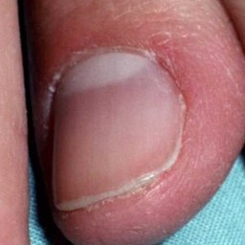  
 normal#1011  
**Analysis by this app:**normal = 26%; non-serious = 1%; check with a GP = 73%;   
It is most likely that the nail indicates something that warrants a second opinion and you should seek medical advice. (Confidence score is 73%)×

 normal#176  
**Analysis by this app:**normal = 26%; non-serious = 72%; check with a GP = 2%;   
The nail's condition is non-serious with confidence score of 72%.  
Otherwise it is normal with confidence score of 26%.×

 normal#71  
**Analysis by this app:**normal = 25%; non-serious = 75%; check with a GP = 0%;   
The nail's condition is non-serious with confidence score of 75%.  
Otherwise it is normal with confidence score of 25%.×

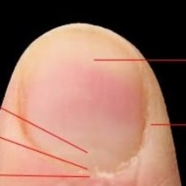  
 normal#1261  
**Analysis by this app:**normal = 24%; non-serious = 44%; check with a GP = 32%;   
Not very sure whether the nail is OK or not. Sorry.×

 normal#226  
**Analysis by this app:**normal = 22%; non-serious = 78%; check with a GP = 1%;   
The nail's condition is non-serious with confidence score of 78%.  
Otherwise it is normal with confidence score of 22%.×

 normal#106  
**Analysis by this app:**normal = 16%; non-serious = 25%; check with a GP = 59%;   
Not very sure whether the nail is OK or not. Sorry.×

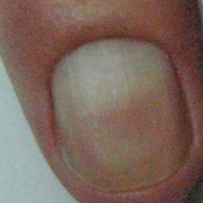  
 normal#1066  
**Analysis by this app:**normal = 16%; non-serious = 57%; check with a GP = 27%;   
Not very sure whether the nail is OK or not. Sorry.×

 normal#231  
**Analysis by this app:**normal = 15%; non-serious = 85%; check with a GP = 0%;   
The nail's condition is non-serious with confidence score of 85%.  
Otherwise it is normal with confidence score of 15%.×

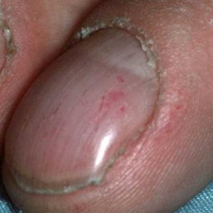  
 normal#1161  
**Analysis by this app:**normal = 14%; non-serious = 78%; check with a GP = 8%;   
The nail's condition is non-serious with confidence score of 78%.  
Otherwise it is normal with confidence score of 14%.×

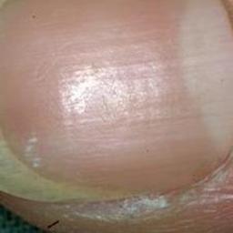  
 normal#1291  
**Analysis by this app:**normal = 14%; non-serious = 71%; check with a GP = 15%;   
The nail's condition is non-serious with confidence score of 71%.  
The confidence score for consulting a GP is 15%.×

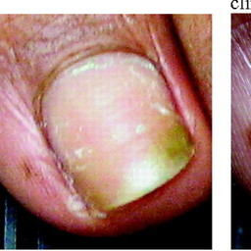  
 normal#1081  
**Analysis by this app:**normal = 12%; non-serious = 80%; check with a GP = 8%;   
The nail's condition is non-serious with confidence score of 80%.  
Otherwise it is normal with confidence score of 12%.×

 normal#381  
**Analysis by this app:**normal = 12%; non-serious = 50%; check with a GP = 37%;   
Not very sure whether the nail is OK or not. Sorry.×

 normal#276  
**Analysis by this app:**normal = 11%; non-serious = 50%; check with a GP = 39%;   
Not very sure whether the nail is OK or not. Sorry.×

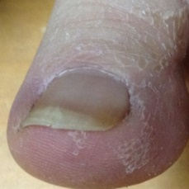  
 normal#1051  
**Analysis by this app:**normal = 10%; non-serious = 83%; check with a GP = 7%;   
The nail's condition is non-serious with confidence score of 83%.  
Otherwise it is normal with confidence score of 10%.×

 normal#461  
**Analysis by this app:**normal = 7%; non-serious = 3%; check with a GP = 90%;   
It is most likely that the nail indicates something that warrants a second opinion and you should seek medical advice. (Confidence score is 90%)×

 normal#236  
**Analysis by this app:**normal = 5%; non-serious = 94%; check with a GP = 0%;   
The nail's condition is non-serious with confidence score of 94%.  
Otherwise it is normal with confidence score of 5%.×

 normal#331  
**Analysis by this app:**normal = 5%; non-serious = 67%; check with a GP = 28%;   
Perhaps a GP should be consulted (confidence score is 28%) ×

 normal#721  
**Analysis by this app:**normal = 3%; non-serious = 3%; check with a GP = 94%;   
It is most likely that the nail indicates something that warrants a second opinion and you should seek medical advice. (Confidence score is 94%)×

 normal#701  
**Analysis by this app:**normal = 3%; non-serious = 96%; check with a GP = 1%;   
The nail's condition is non-serious with confidence score of 96%.  
Otherwise it is normal with confidence score of 3%.×

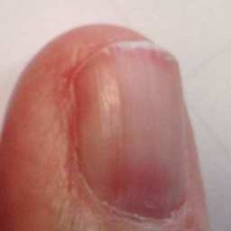  
 normal#1026  
**Analysis by this app:**normal = 2%; non-serious = 24%; check with a GP = 74%;   
It is most likely that the nail indicates something that warrants a second opinion and you should seek medical advice. (Confidence score is 74%)×

 normal#66  
**Analysis by this app:**normal = 2%; non-serious = 14%; check with a GP = 84%;   
It is most likely that the nail indicates something that warrants a second opinion and you should seek medical advice. (Confidence score is 84%)×

 normal#11  
**Analysis by this app:**normal = 1%; non-serious = 5%; check with a GP = 94%;   
It is most likely that the nail indicates something that warrants a second opinion and you should seek medical advice. (Confidence score is 94%)×

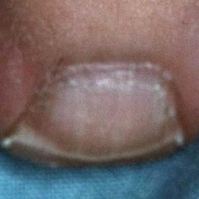  
 normal#1191  
**Analysis by this app:**normal = 1%; non-serious = 99%; check with a GP = 0%;   
The nail's condition is non-serious with confidence score of 99%.  
Otherwise it is normal with confidence score of 1%.×